GPT Kampli Library User Manual

**Contents**

**1. Introduction 1**

**Welcome to GPTK Library Management System 1**

Core Capabilities 1

Navigating the System 1

**2. Authentication 3**

**Smart Authentication & Security 3**

1. Intelligent Role-Based Login 3

2. OTP-Verified Password Recovery 4

**3. Initial Setup 5**

**System Initialization & First-Run Wizard 5**

1. Database Configuration 5

2. Super Admin Creation 5

**4. Dashboard 7**

**The Dashboard & Navigation Hub 7**

Sidebar Navigation 7

Real-Time Analytics Cards 8

**5. Header & Settings 9**

**Global Controls 9**

**6. Book Catalog 10**

**The Knowledge Repository 10**

1. The Catalog Dashboard 10

2. Adding New Titles 10

3. Lifecycle Management 12

**7. Student Management 13**

**Member Administration 13**

1. Student Directory 13

2. Registration 13

3. Digital ID Cards 14

4. Profile Management 15

5. Export Data 16

**8. Department Management 17**

**Organization & Hierarchy 17**

Creating Departments 17

Modifying Details 18

**9. Circulation Desk 19**

**Circulation Operations 19**

1. Circulation Dashboard 19

2. Issuing Books (Checkout) 19

3. Returning Books (Check-in) 20

4. Fine Management 21

5. Receipt Verification 22

**10. Transaction History 23**

**Financial Audit Trail 23**

1. The Log 23

2. Details & Receipts 23

3. Reporting 24

**11. Reports & Analytics 25**

**Strategic Insights 25**

1. Daily Activity 25

2. Analytics & Trends 25

3. Custom Exports 26

**12. Staff Management 27**

**Workforce Management 27**

Adding Staff 27

Account Maintenance 28

**13. Admin Management 29**

**System Administration 29**

Creating Admins 29

Managing Credentials 29

**14. Audit Logs 31**

**Security & Accountability 31**

1. Activity Monitoring 31

2. Compliance Export 31

**15. System Policies 32**

**Operational Rules Engine 32**

Circulation Rules 32

Financial Rules 32

**16. System Settings 33**

**Global Configuration Hub 33**

1. Appearance 33

2. Hardware 33

3. Security 34

4. Data & Maintenance 35

A. Creating a Cloud Database (MongoDB Atlas) 35

5. Email Configuration 36

**17. System Health 38**

**Diagnostics Dashboard 38**

**18. Public Pages 39**

**Landing & About 39**

# 1. Introduction

# Welcome to GPTK Library Management System

The **GPTK Library Management System (LMS)** is a state-of-the-art desktop application meticulously designed to digitize and automate the entire workflow of the Government Polytechnic Kampli library. Built for speed, reliability, and ease of use, it transforms traditional library operations into a seamless digital experience.

**Release 1.0:**Now featuring a completely redesigned interface with dark mode support, enhanced reporting analytics, and automated student data imports.

## Core Capabilities

Designed to serve librarians, faculty, and students, the system integrates five key pillars of library management:

* **Catalog Management:** A powerful search and inventory system for thousands of books.
* **Smart Circulation:** Lightning-fast issue/return process using barcode scanning or manual entry.
* **Member Administration:** Comprehensive student and staff databases with digital ID card generation.
* **Financial Tracking:** Automated fine calculation, due date management, and transaction logging.
* **Actionable Insights:** Real-time dashboards and detailed PDF/Excel reports for decision-making.

## Navigating the System

The interface is divided into two main areas for maximum productivity:

* **The Sidebar:** Located on the left, this is your primary navigation menu to access different modules like Books, Students, and Settings.
* **The Dashboard:** Your home screen, displaying vital statistics like total books, active issues, and overdue alerts at a glance.

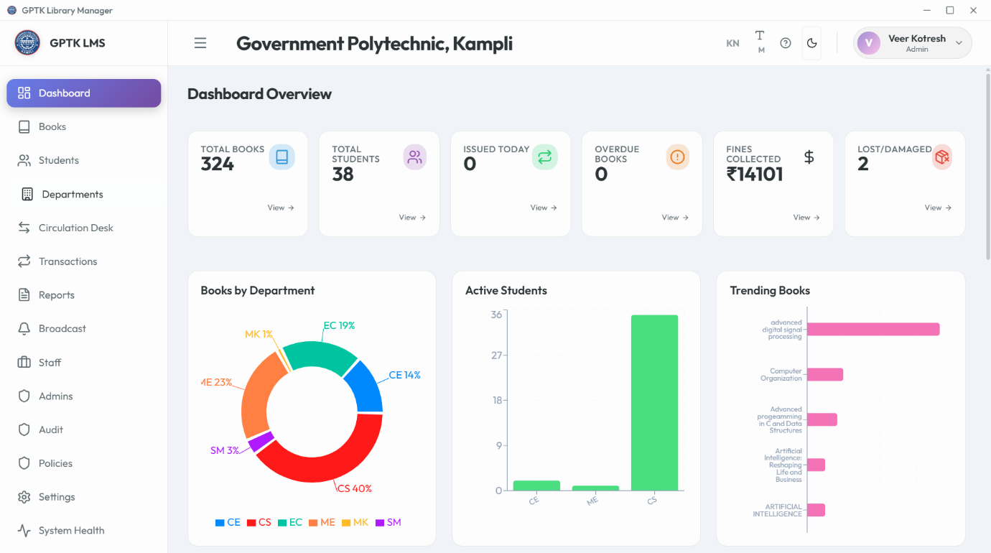

*Figure 1.1: Main Dashboard with Key Performance Indicators*

# 2. Authentication

# Smart Authentication & Security

The system employs extensive security protocols to ensure that sensitive library data remains protected while offering seamless access to authorized personnel.

**Security Note:** The application uses industry-standard encryption for passwords and maintains a secure, local-first database environment.

## 1. Intelligent Role-Based Login

Access is strictly controlled through a **Role-Based Access Control (RBAC)** system. Your dashboard experience automatically adapts based on your assigned credentials:

* **Admins:** Full system control including settings, staff management, and audit logs.
* **Staff:** Operational access for circulation and member management, restricted from critical system configs.
* **Librarians:** Dedicated view for cataloging and day-to-day library operations.

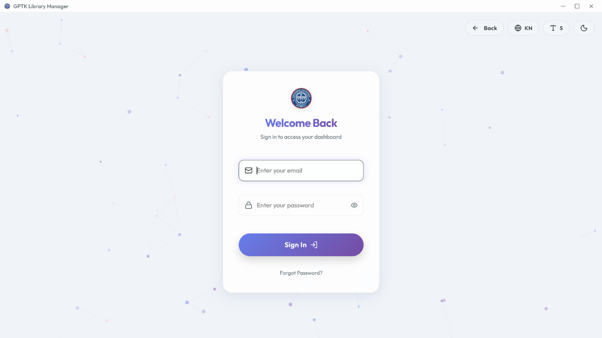

*Figure 2.1: Secure Login Interface*

**Smart Login Features:**

* **Account Locking:** Prevents brute-force attacks by locking accounts after multiple failed attempts.
* **Show/Hide Password:** Toggle visibility to prevent typing errors.
* **Enter-to-Submit:** Optimized for keyboard-only workflow.

## 2. OTP-Verified Password Recovery

Forgot your credentials? The system includes a secure, OTP-based recovery mechanism to restore access without admin intervention.

**Recovery Flow:**

1. Click **Forgot Password?** on the login screen.
2. Enter your registered **Email Address**.
3. Input the **6-digit OTP** sent to your inbox.
4. Set a new, **Strong Password**.

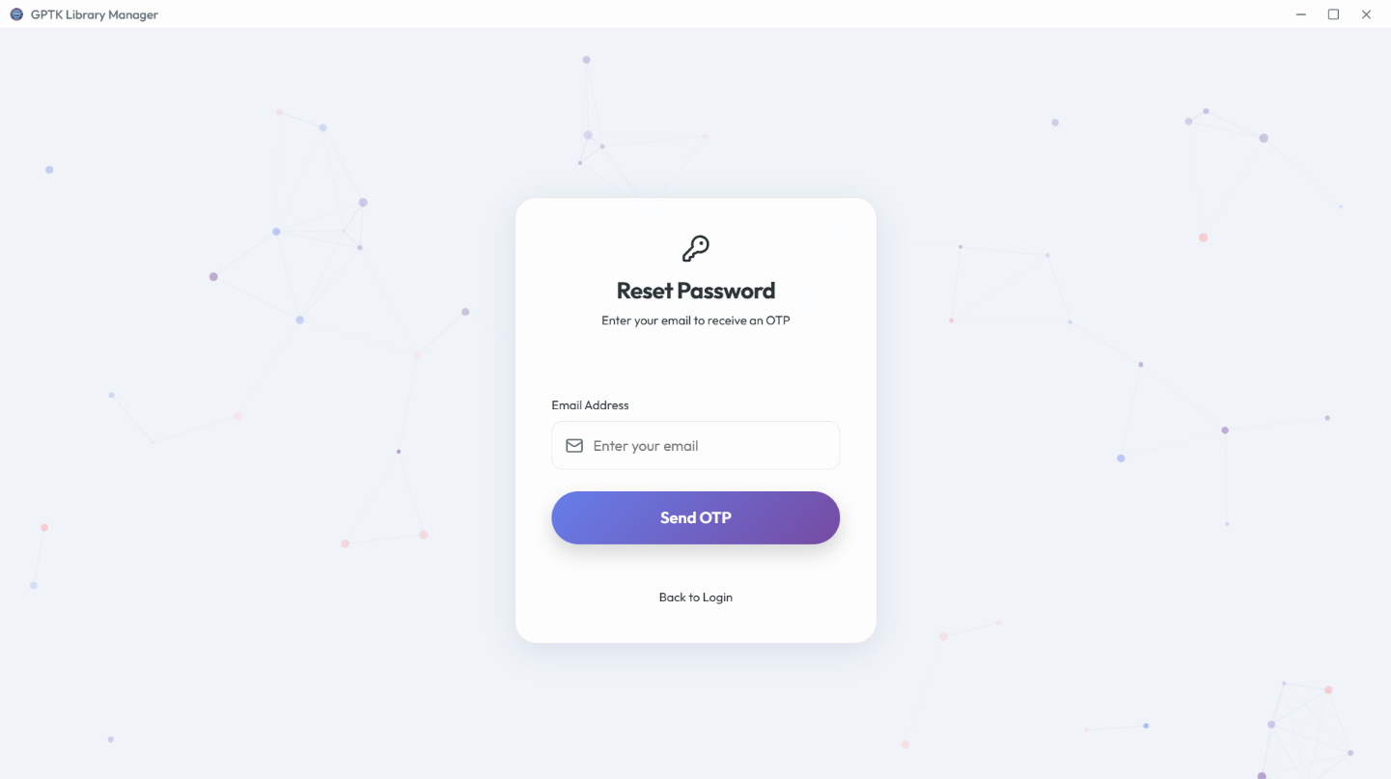

*Figure 2.2: Secure Password Reset Flow*

# 3. Initial Setup

# System Initialization & First-Run Wizard

Welcome to the GPTK Library Management System. Upon first launch, the application initiates a comprehensive **System Health Check** and guides you through the essential configuration steps to prepare the database for production use.

**Network Requirement:** Ensure you are connected to the internet during initial setup to allowing fetching of metadata and updates.

## 1. Database Configuration

The system automatically initializes the embedded MongoDB environment. No manual database installation is required. Data is stored locally at:

* **Database:** ./data/db
* **Backups:** ./backups
* **Logs:** ./logs/app.log

## 2. Super Admin Creation

The first user created is granted **Super Admin** privileges. This account has irrevocable access to the entire system and cannot be deleted.

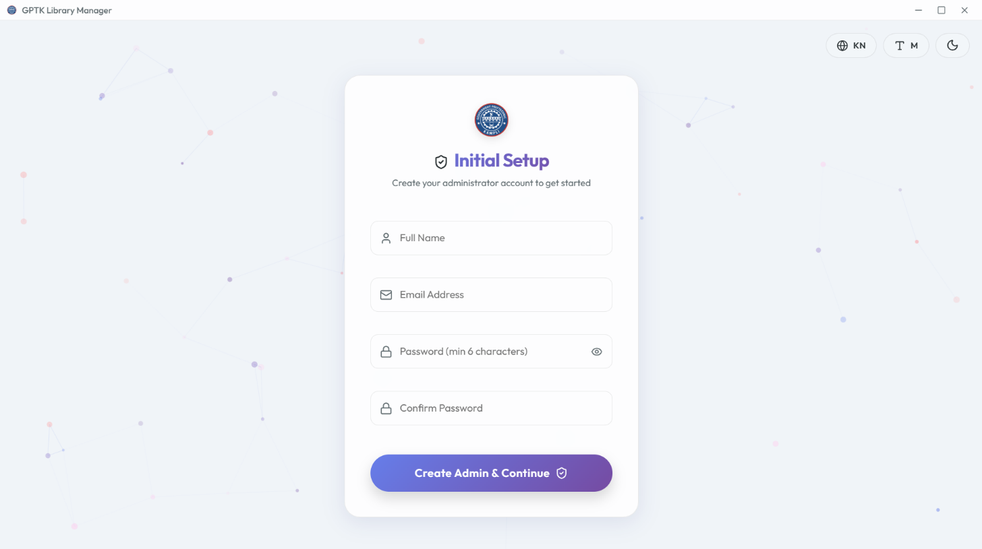

*Figure 3.1: Admin Account Creation*

**Configuration Steps:**

1. Launch the application via LibraryManager.exe.
2. Enter the unique **Institution ID** (provided upon license purchase).
3. Create your admin credentials (Username & Password).
4. **System Handshake:** The app verifies integrity and creates necessary encryption keys.

**Important:** Do not close the application window during the "Initializing Database..." phase to prevent data corruption.

# 4. Dashboard

# The Dashboard & Navigation Hub

The Dashboard serves as the command center of the GPTK Library Management System, offering a real-time panoramic view of library operations and instant access to all modules.

## Sidebar Navigation

An intuitive, collapsible vertical menu providing one-click access to:

* **Core Modules:** Books, Students, Departments.
* **Circulation Desk:** Issue, Return, and Renewals.
* **Admin Tools:** Staff, Settings, Audit Logs.
* **Analytics:** Daily Reports and Trends.

**Pro Tip:** Click the library logo at the top-left to instantly return to the Dashboard from any screen.

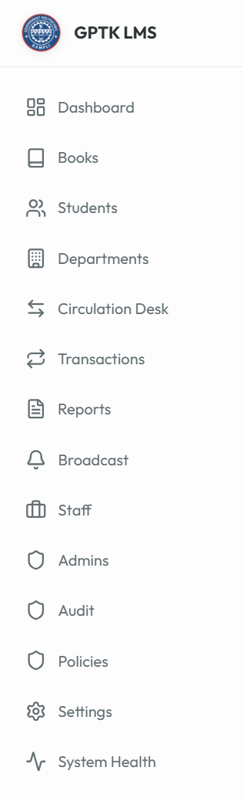

*Figure 4.1: Navigation Sidebar*

## Real-Time Analytics Cards

Live data widgets that pulse with activity:



*Figure 4.2: Real-time Dashboard Analytics*

* **Total Books:** Current count of distinct titles in the catalog.
* **Active Issues:** Number of books currently out on loan.
* **Circulation Velocity:** Books issued in the last 24 hours.
* **Overdue Alerts:** Critical count of books past their due date.

# 5. Header & Settings

# Global Controls

The top navigation bar persists across all screens, offering quick access to personal preferences and system-wide toggles.



*Figure 5.1: Application Header*

* **Language Switcher:** Toggle between English and Kannada interfaces instantly.
* **Font Sizer:** Increase/Decrease text size for accessibility.
* **Theme Toggle:** Switch between Light and Dark modes.
* **Profile Menu:** Access account settings or Logout safely.

# 6. Book Catalog

# The Knowledge Repository

The **Book Catalog** is the heart of the library. It is designed to handle thousands of records with sub-millisecond search retrieval.

## 1. The Catalog Dashboard

View, sort, and manage your entire collection in a tabular grid.

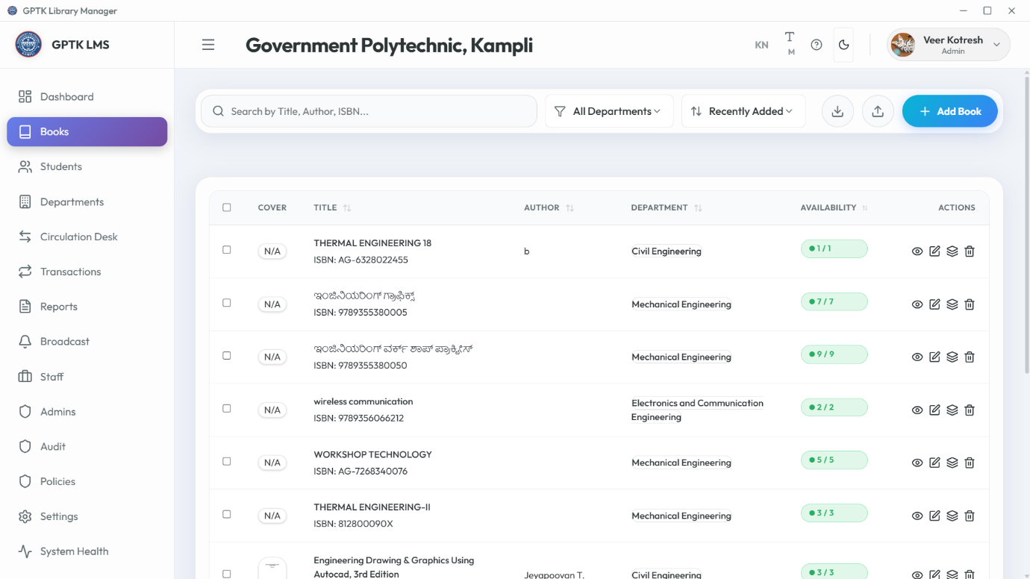

*Figure 6.1: Master Catalog View*

* **Smart Search:** Find books by Title, Author, Publisher, or ISBN.
* **Advanced Filters:** Drill down by Category, Language, or Availability status.
* **Quick Actions:** Edit, Delete, or View Details for any row.

## 2. Adding New Titles

Expand your library with a streamlined entry process.

**Method A: Manual Entry**

1. Click **Add New Book**.
2. **Scan ISBN:** Use a handheld scanner to auto-fill metadata.
3. Enter details: Title, Author, Publisher, Price, etc.
4. Assign a **Category** and Shelf Location.

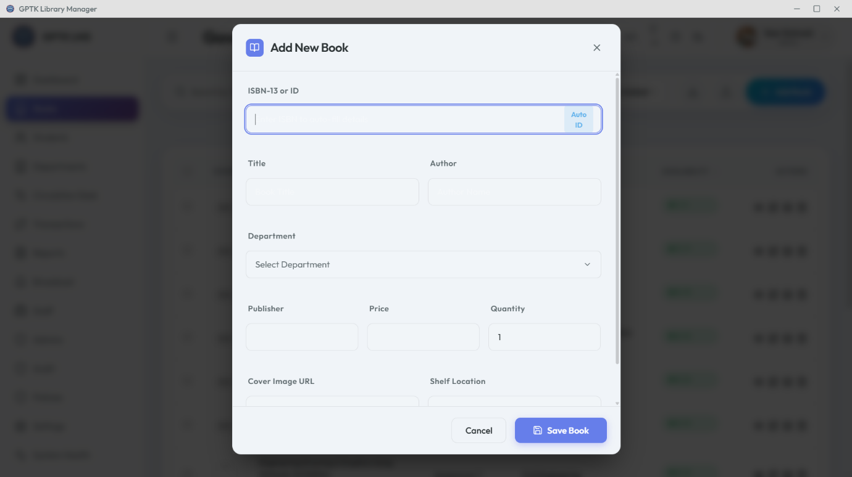

*Figure 6.2: Book Entry Form*

**Method B: Bulk Import (CSV)**

Migrating from an old system? Import thousands of records in seconds.

* **Template:** Download the pre-formatted CSV template.
* **Validation:** The system pre-checks for duplicate ISBNs before import.
* **CSV Format:** Ensure headers match: Title, Author, ISBN, Publisher, Price, Category, Copies.

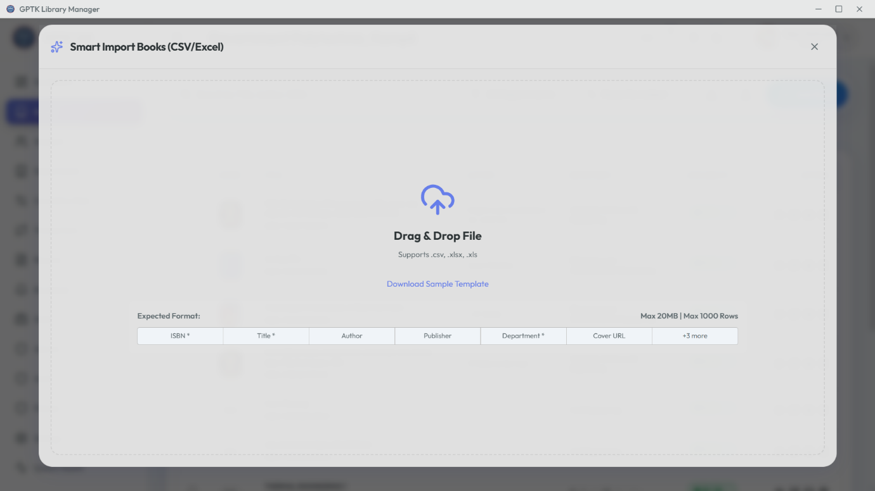

*Figure 6.3: Bulk Import Tool*

## 3. Lifecycle Management

**Book Details**

View complete history, including current borrower and past circulation stats.

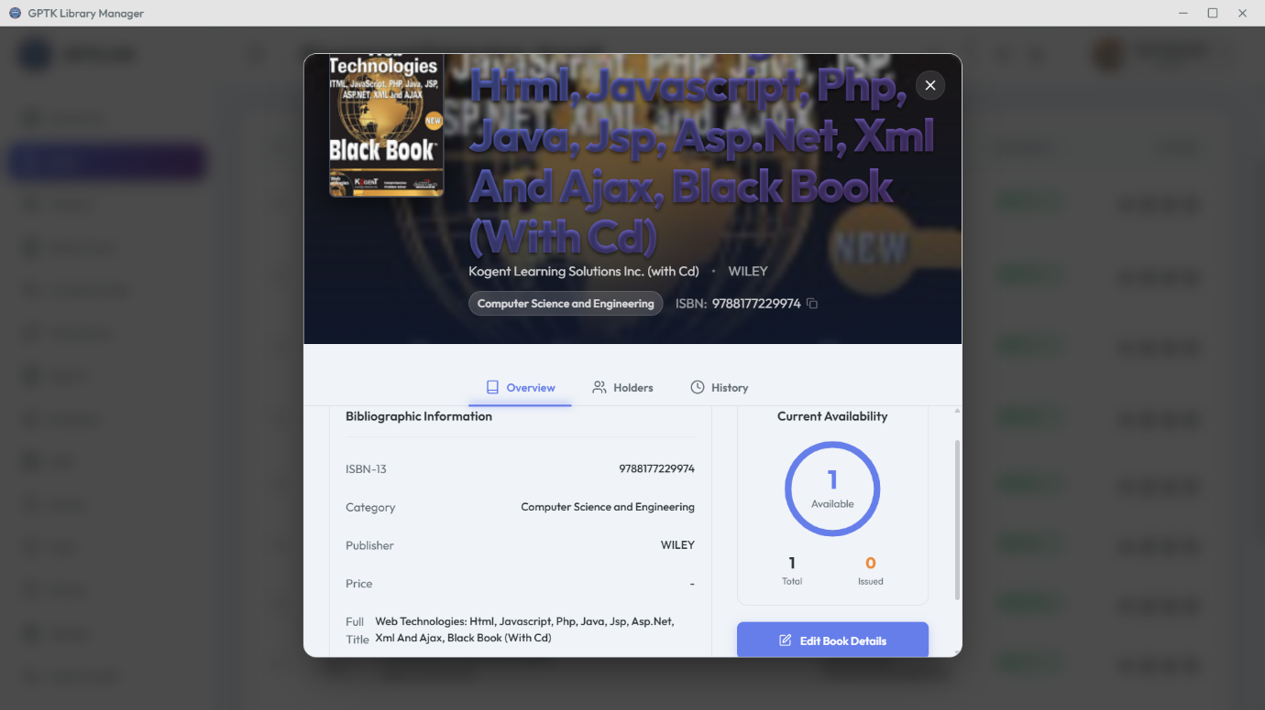

**Managing Copies**

Track individual physical copies of the same title, each with a unique accession number.

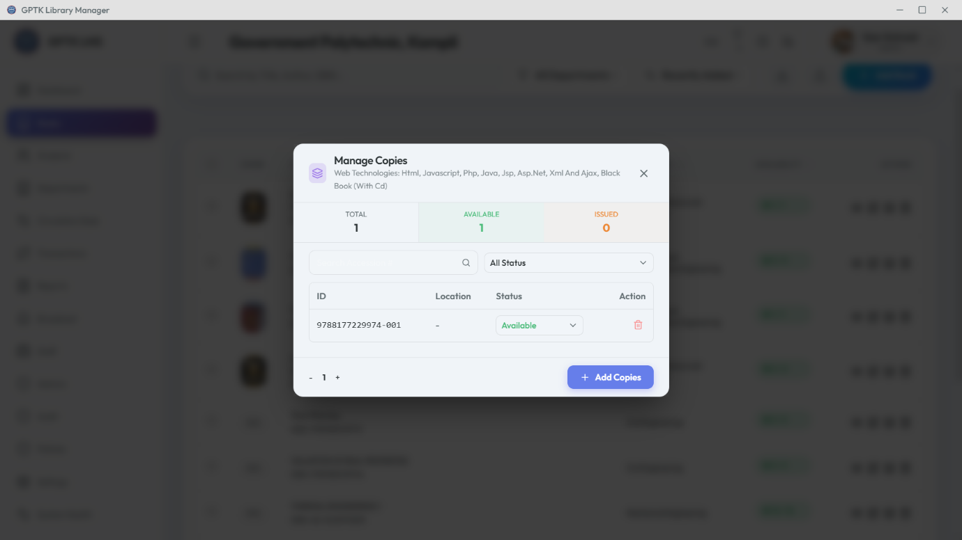

# 7. Student Management

# Member Administration

Manage the entire student lifecycle, from admission to alumni status. The centralized directory links students to their transaction history.

## 1. Student Directory

A searchable database of all registered library members.

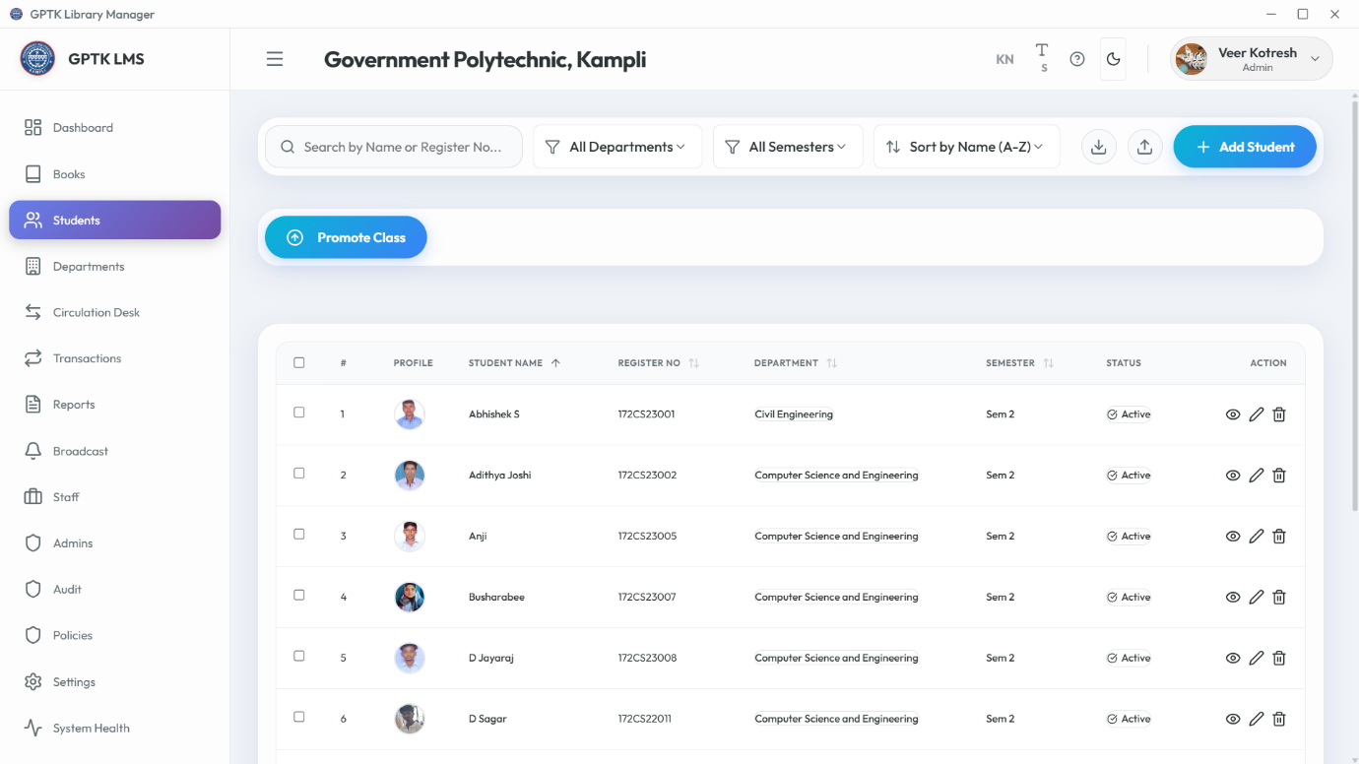

*Figure 7.1: Student Directory*

## 2. Registration

**New Student Entry**

1. Click **Add Student**.
2. **Personal Data:** Name, DOB, Gender.
3. **Academic Data:** Department, Register No (USN), Semester.
4. **Contact:** Email and Mobile for notifications.

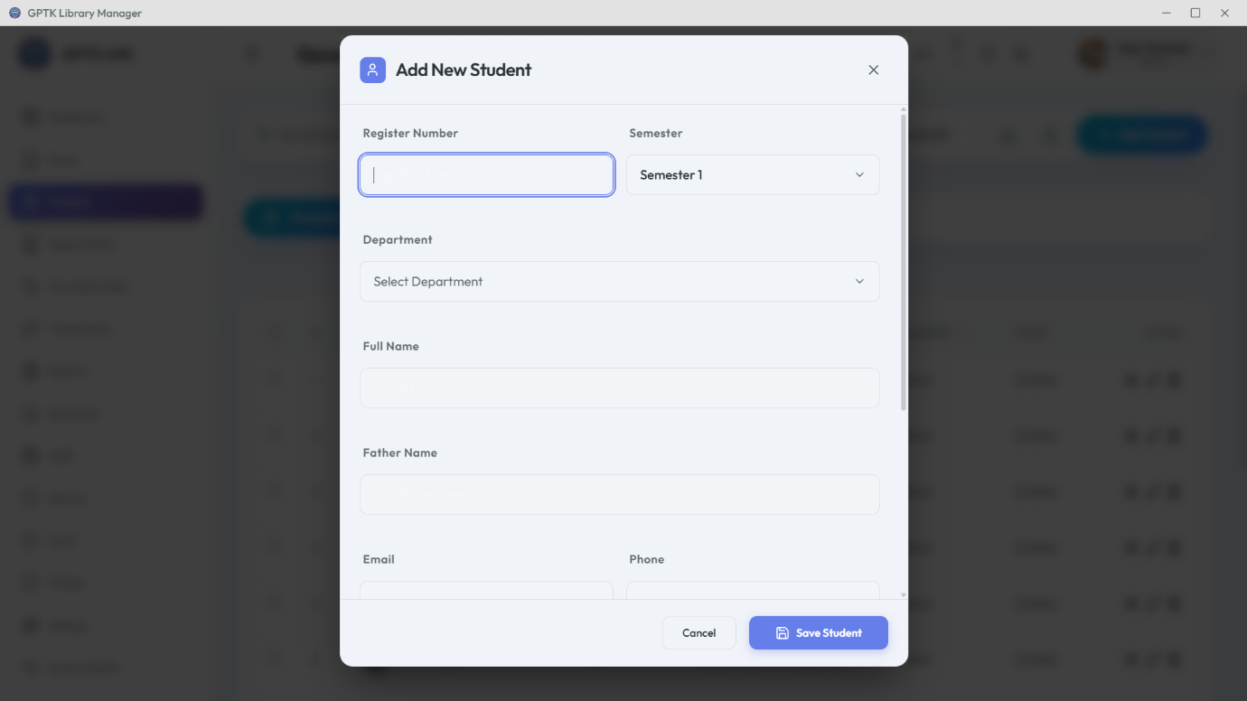

*Figure 7.2: Student Registration*

**Bulk Import (CSV)**

Upload entire class lists using the bulk import tool. The system intelligently maps columns and highlights errors.

**CSV Headers:** Required columns: Name, Register Number, Department, Semester, Email, Mobile.

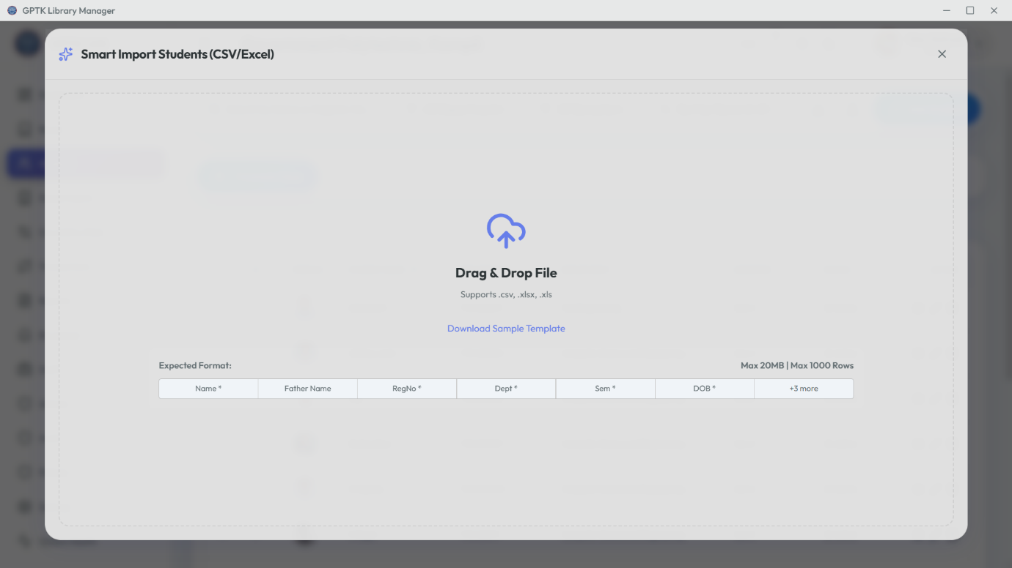

## 3. Digital ID Cards

The system automatically generates printable ID cards with barcodes.

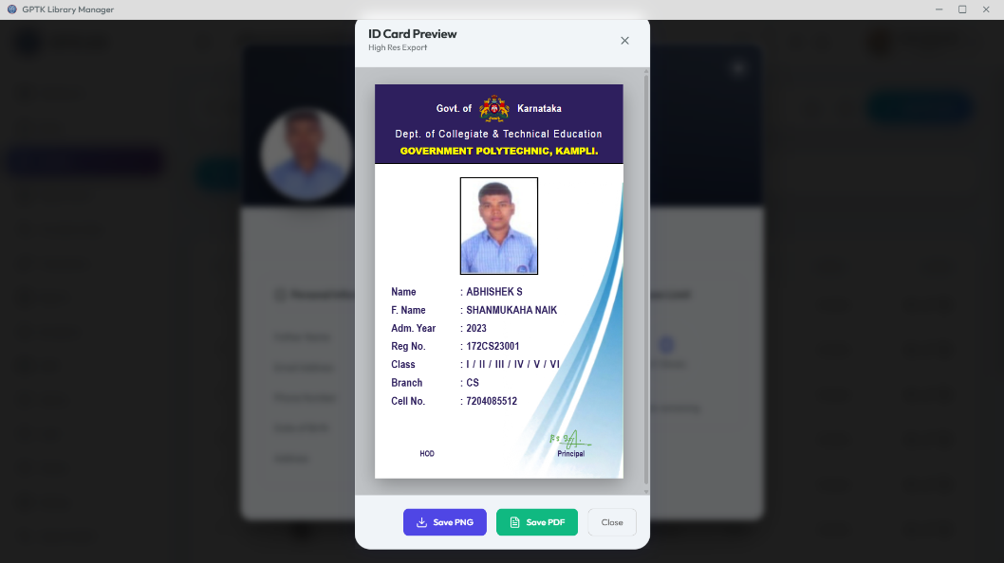

*Figure 7.3: Auto-generated ID Card*

## 4. Profile Management

Inspect comprehensive student profiles, including current loans, fine history, and personal details.

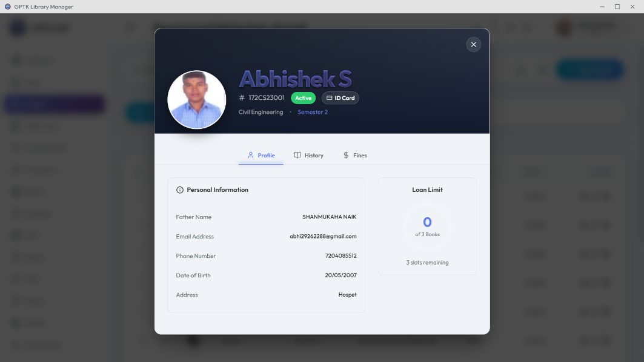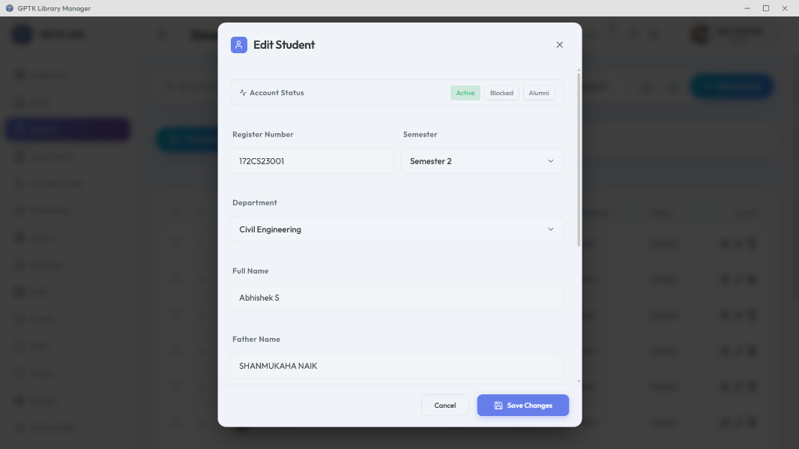

## 5. Export Data

Export student lists for administrative use or ID card printing vendors.

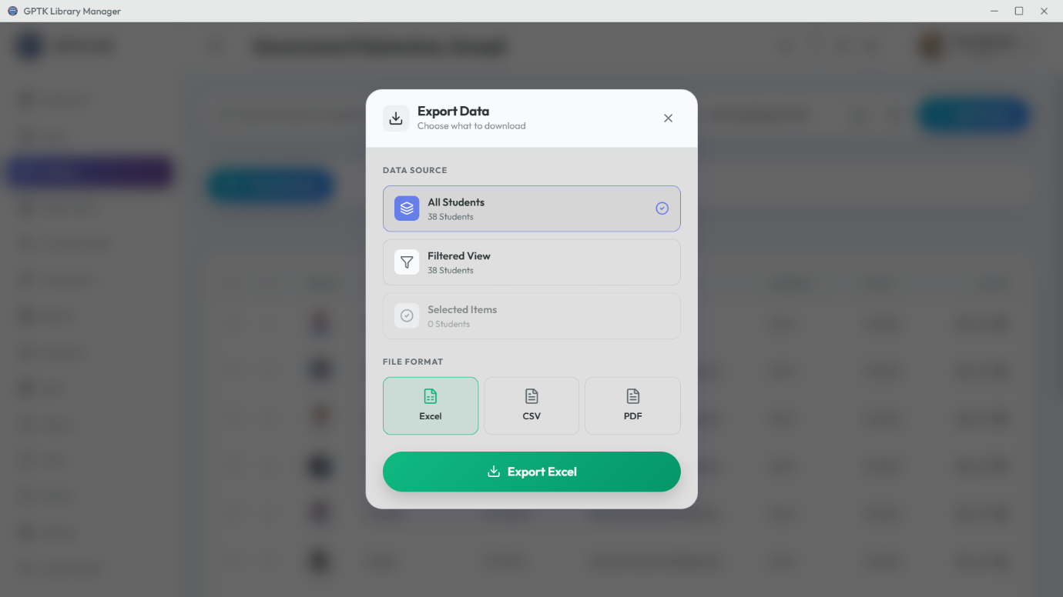

# 8. Department Management

# Organization & Hierarchy

Organize standard academic departments (e.g., Computer Science, Civil Engineering) to group students and analyse departmental usage trends.

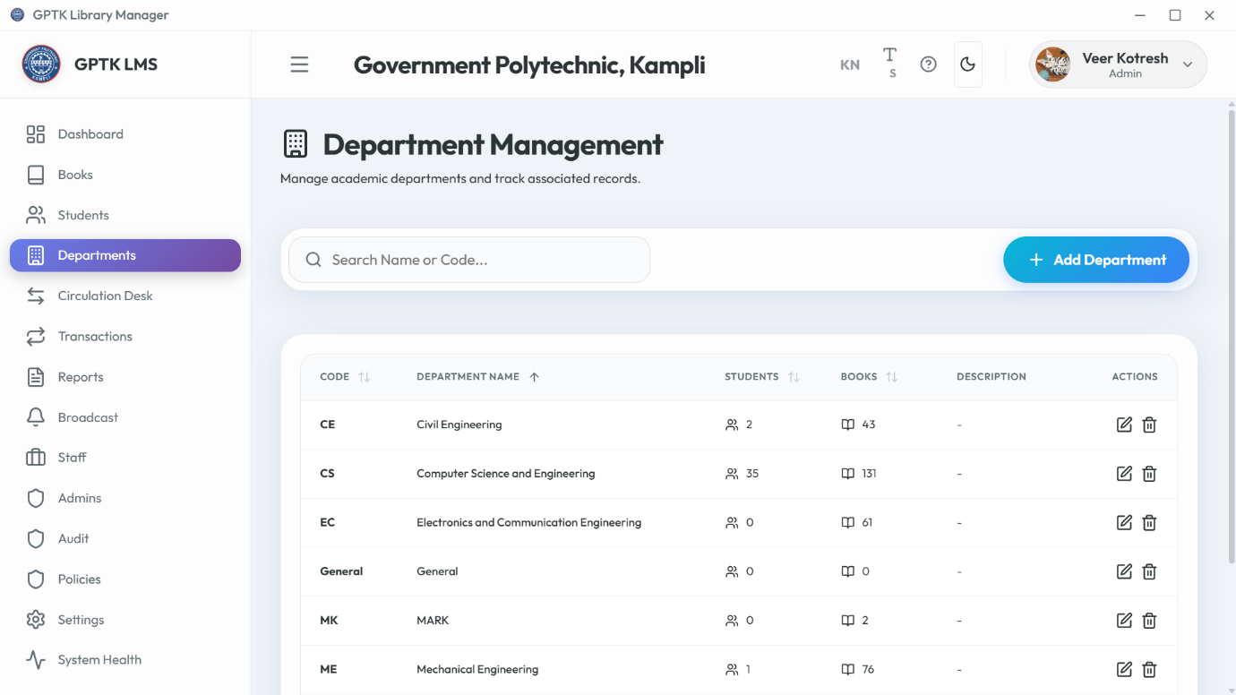

*Figure 8.1: Department List*

## Creating Departments

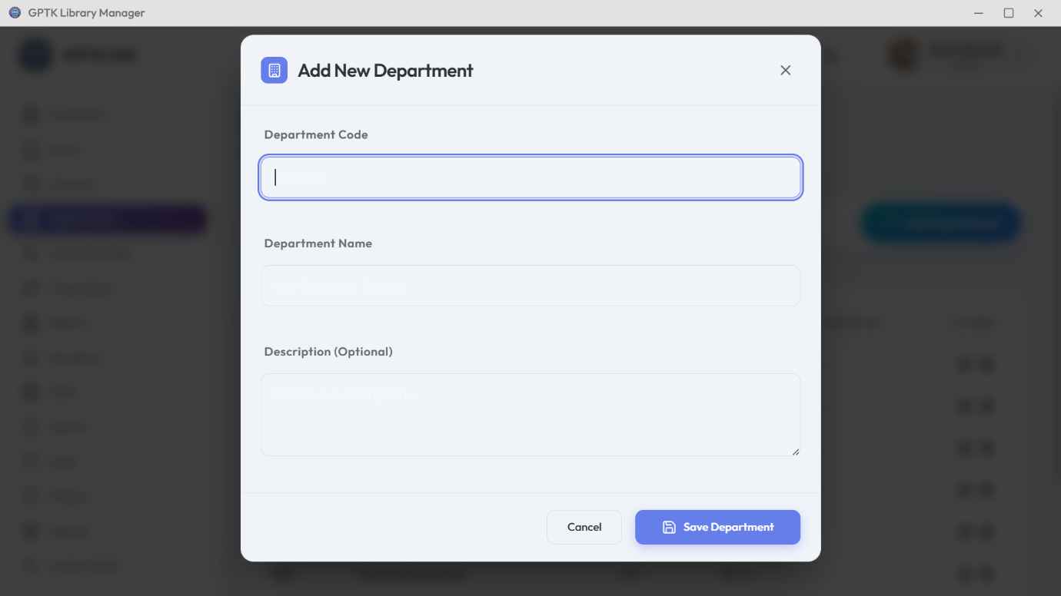

## Modifying Details

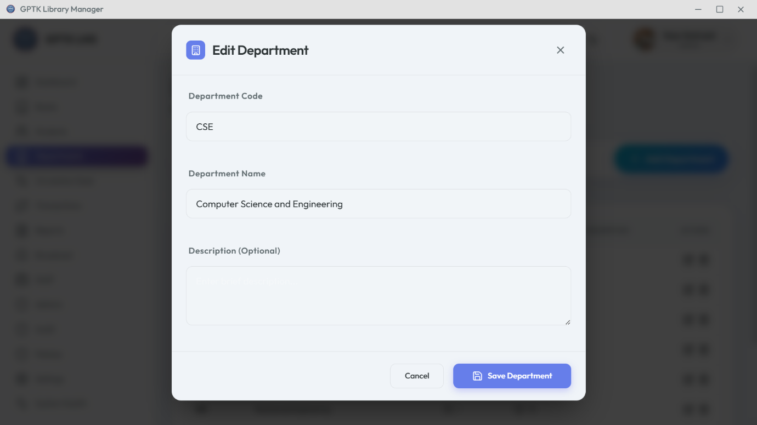

*Note: Renaming a department updates all linked student records automatically.*

**Short Codes:** Assign unique uppercase codes (e.g., CS, ME, EC) for quick identification in reports.

# 9. Circulation Desk

# Circulation Operations

The nerve center of the library. Process issues, returns, and renewals with blazing speed to keep queue times zero.

## 1. Circulation Dashboard

The Unified Interface for all daily transactions.

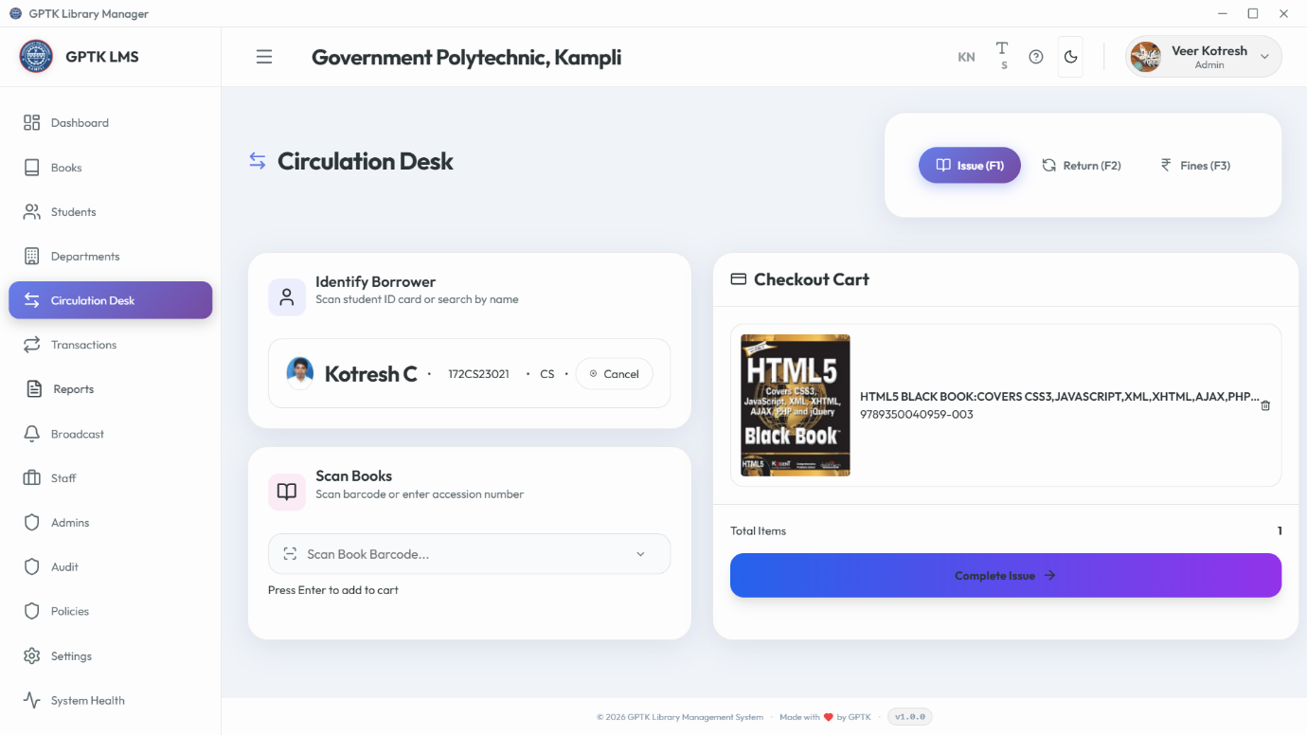

## 2. Issuing Books (Checkout)

**Workflow:**

1. **Select Tab:** Click "Issue" or press F1.
2. **Identify Patron:** Scan Student ID or type Register No.
3. **Identify Item:** Scan Book Accession Number.
4. **Verify & Commit:** Check for blocks/overdues, then click **Issue Book**.

**Shortcut:** Press Enter to instantly fetch details after typing.



*Figure 9.2: Fast Checkout*

## 3. Returning Books (Check-in)

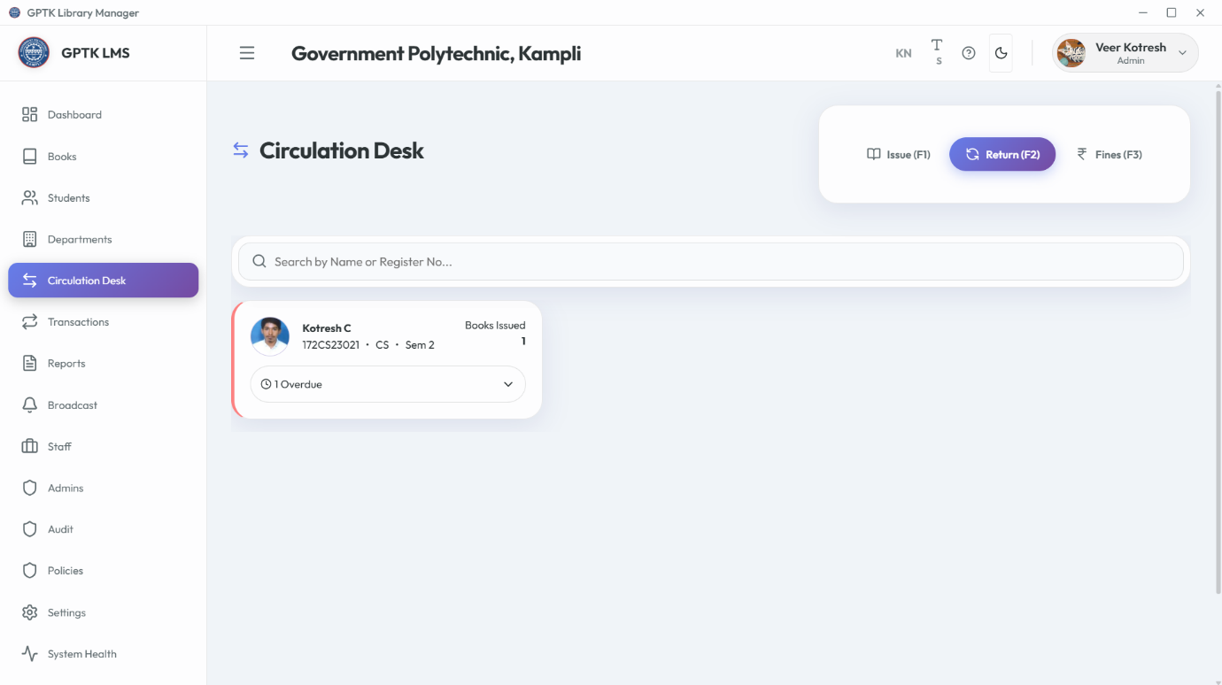

*Figure 9.3: Return & Fines*

**Workflow:**

1. Switch to "Return" tab or press F2.
2. **Scan Item:** Input Accession Number.
3. **Auto-Calc:** System calculates late fees instantly.
4. **Complete:** Click **Return Book**. If fines exist, a payment modal appears.

## 4. Fine Management

The **Fines Tab** (F3) handles due collection and history.

**Collecting Dues**

1. Select student with dues.
2. System shows total amount.
3. Click **Pay** to record transaction.

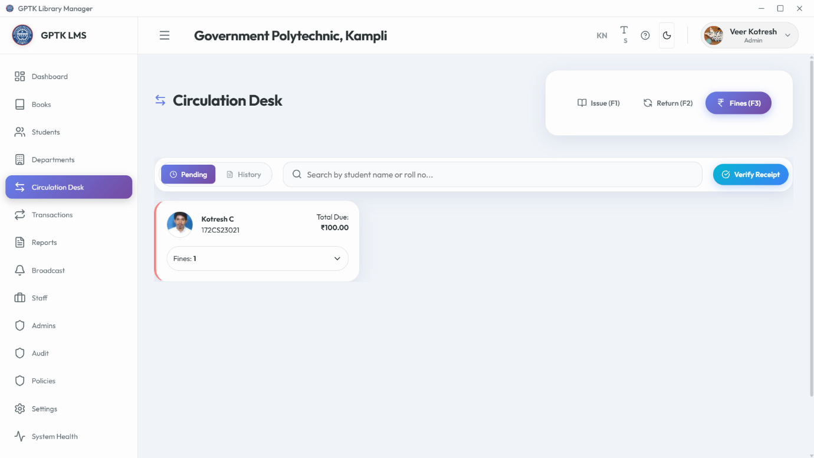

**Fine History**

View detailed ledger of past payments.

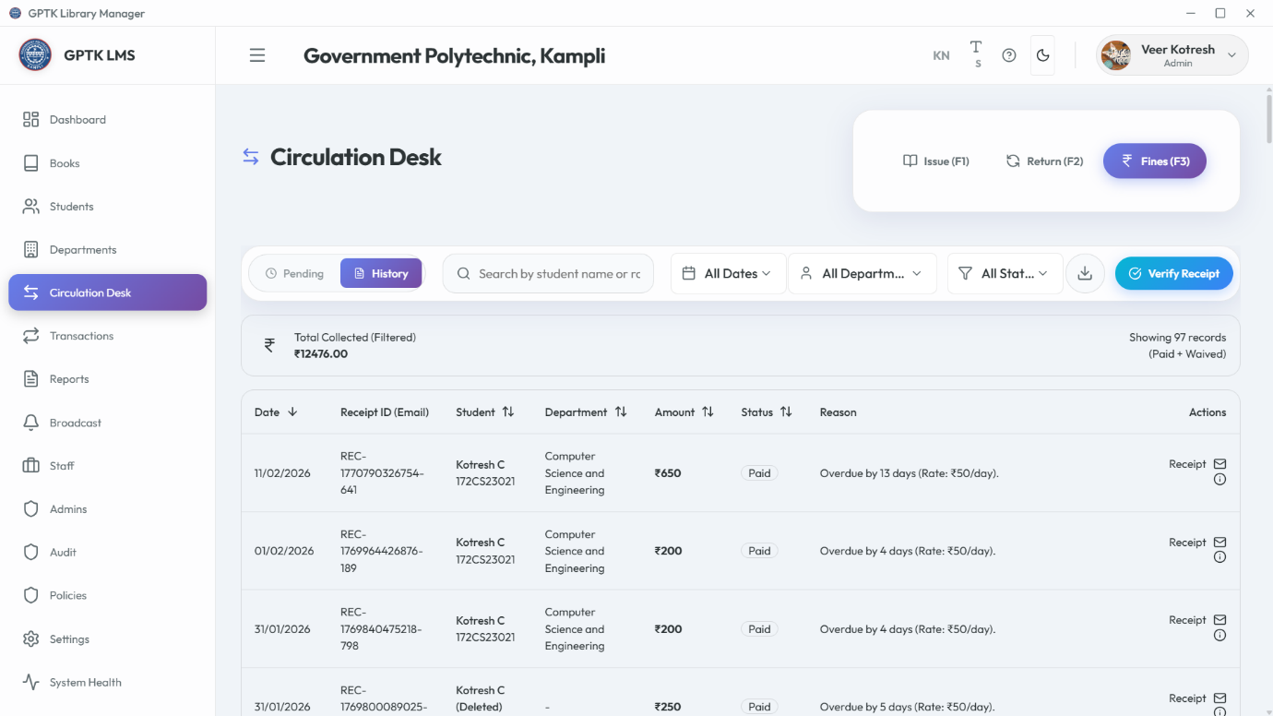

## 5. Receipt Verification

Verify authenticity of physical receipts using the secure digital signature.

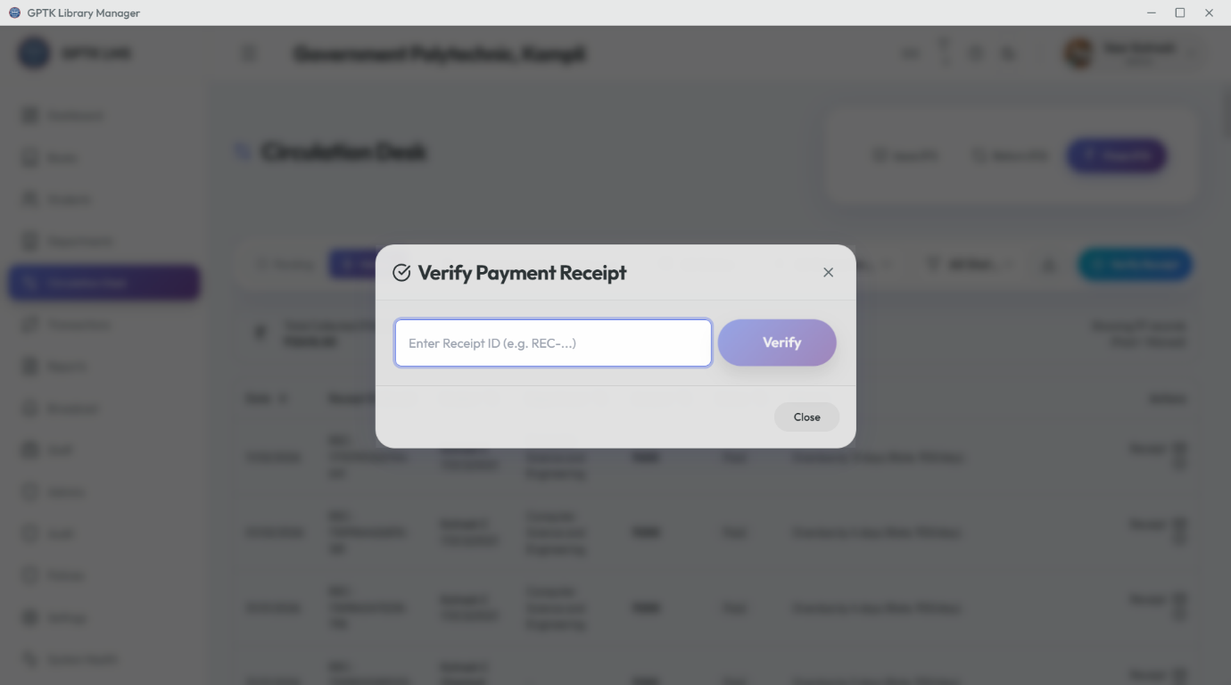

1. Click **Verify Receipt** button.
2. Enter **Receipt ID**.
3. System validates the SHA-256 signature and shows original details.

# 10. Transaction History

# Financial Audit Trail

The **Transaction History** module provides a transparent, immutable ledger of all financial operations. Essential for daily reconciliation.

## 1. The Log

Chronological feed of real-time payments.

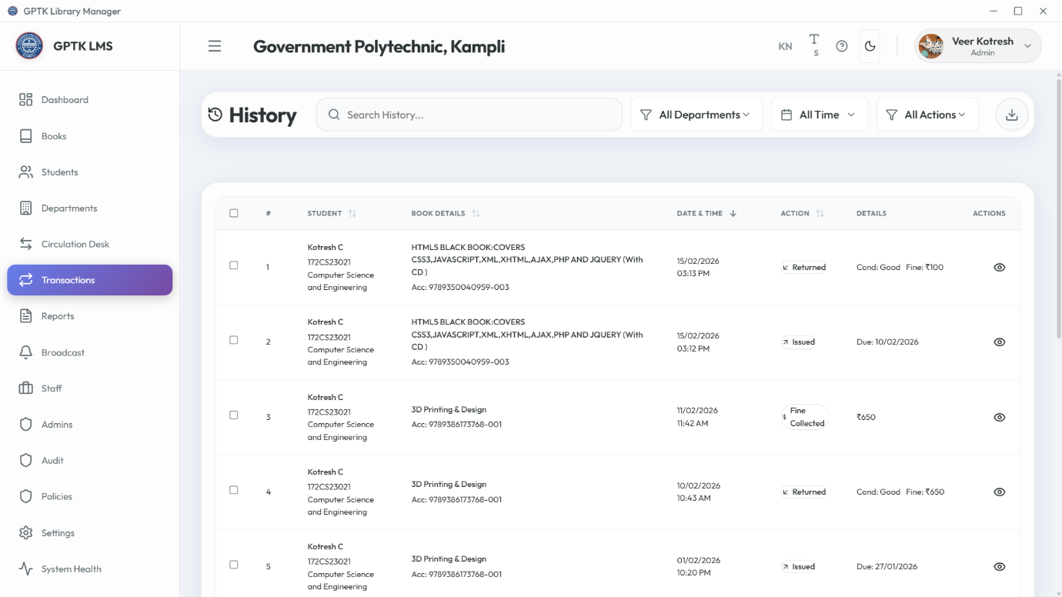

## 2. Details & Receipts

**Inspecting a Record:**

1. Click any row in the table.
2. **Receipt Preview:** View digital receipt.
3. **Metadata:** Check Timestamp, Cashier, Mode.
4. **Status:** Verify success/void status.

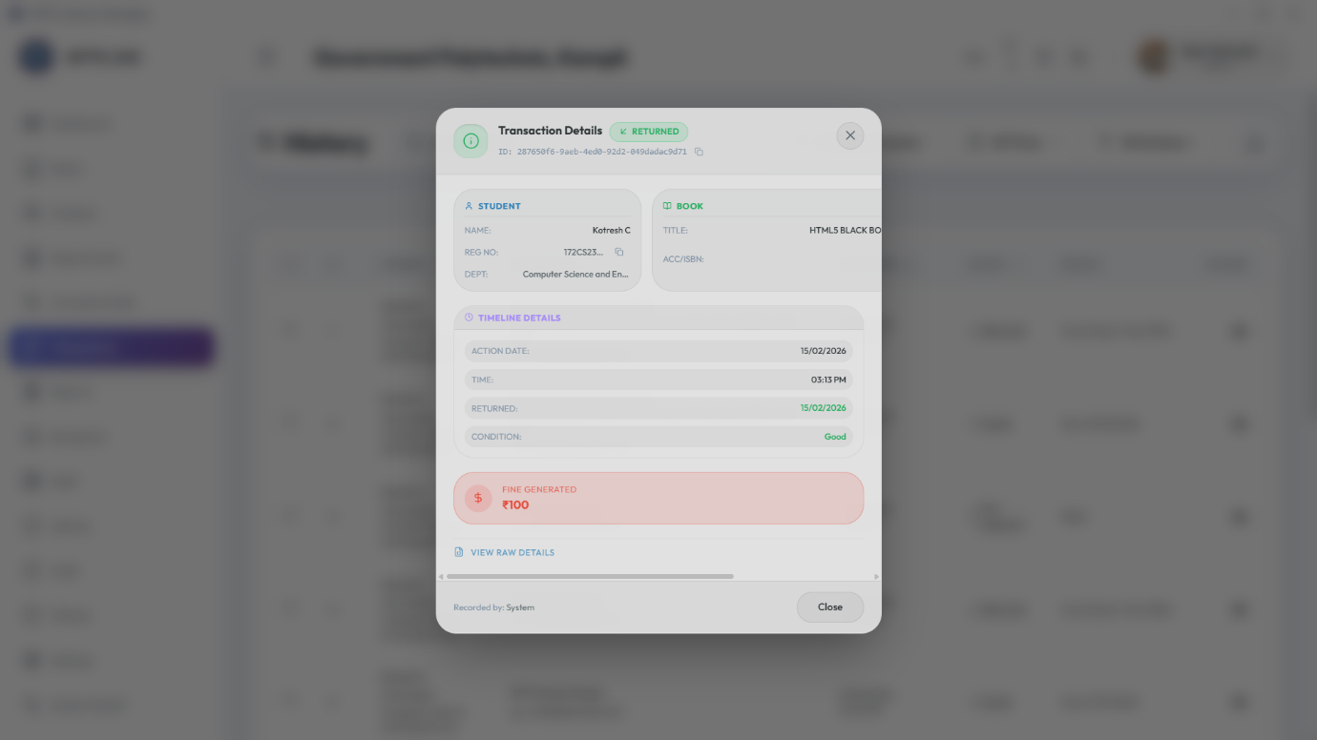

## 3. Reporting

Filter by date range and export to CSV/Excel for accounting.

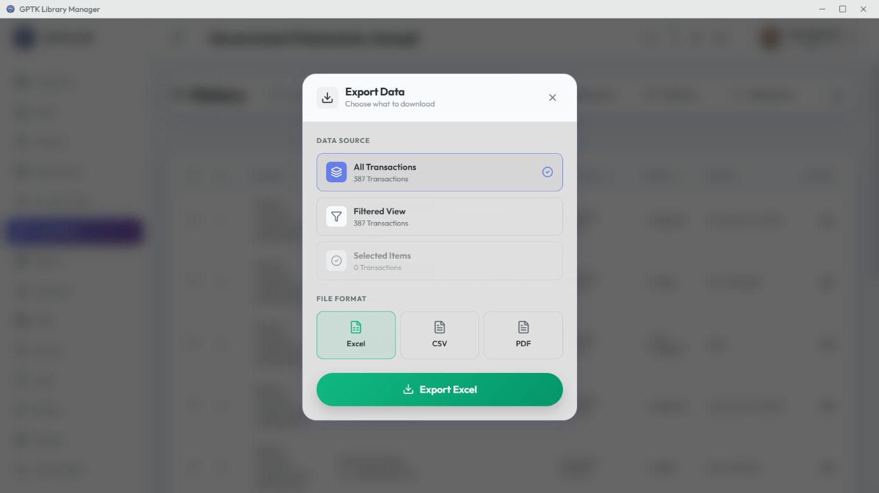

# 11. Reports & Analytics

# Strategic Insights

Transform raw data into actionable intelligence. Track circulation trends and inventory health.

## 1. Daily Activity

Snapshot of today's operations: Check-ins, Check-out, New Registrations, Fine Collections.

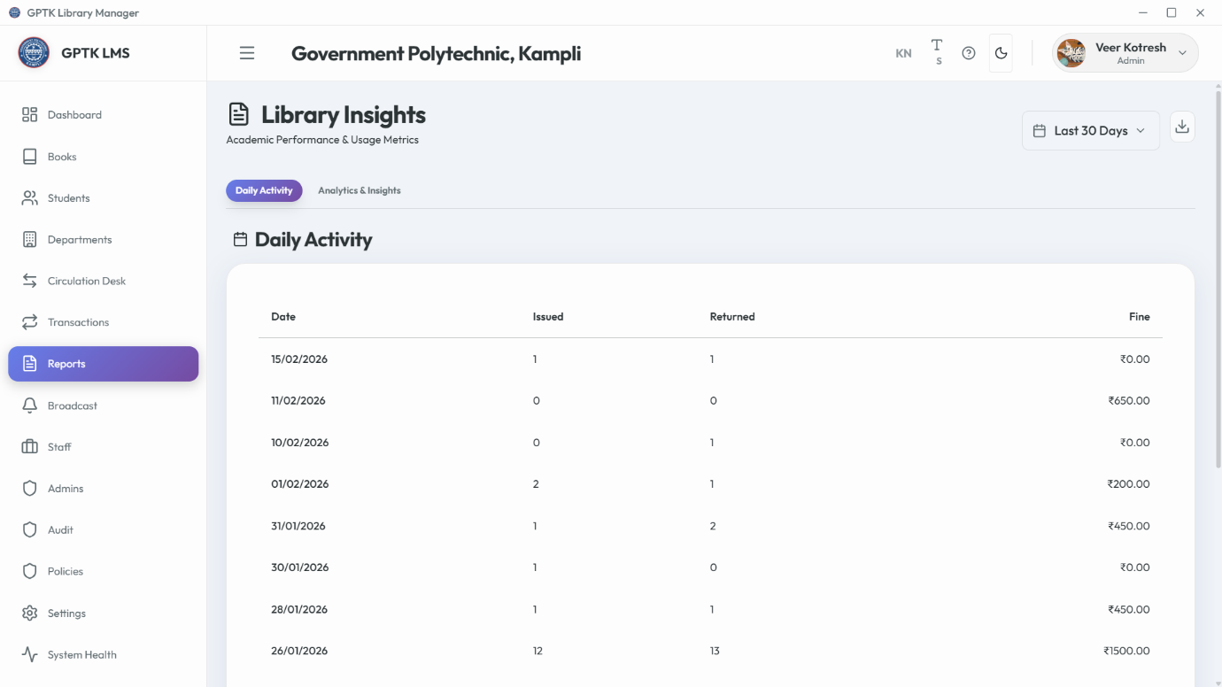

## 2. Analytics & Trends

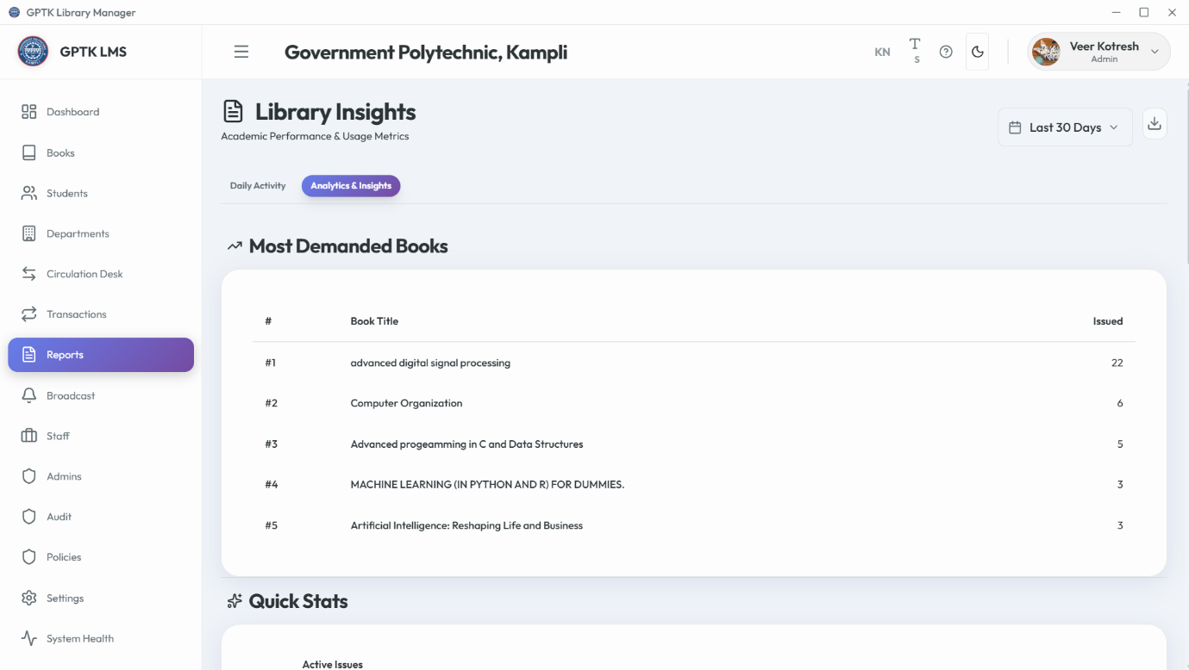

* **Most Issued Books:** Plan procurement based on demand.
* **Peak Hours:** Staff usage analysis.
* **Departmental Usage:** Compare branch engagement.

## 3. Custom Exports

Generate PDF or Excel reports for specific date ranges.

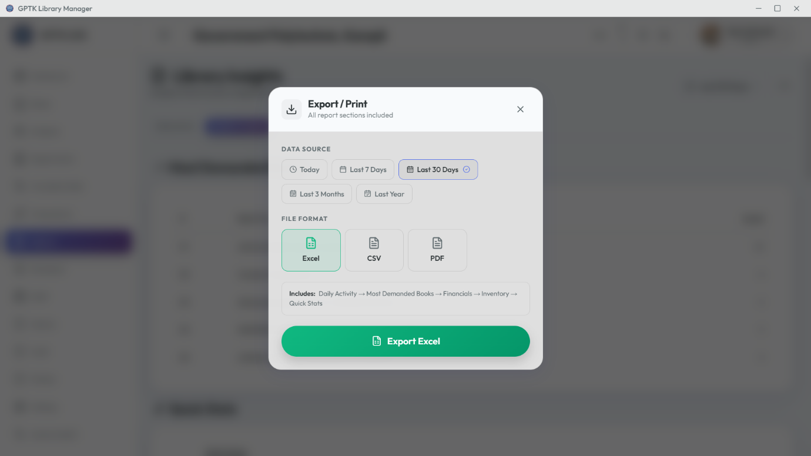

# 12. Staff Management

# Workforce Management

Delegate operations securely. Assign roles to Librarians and Assistants.

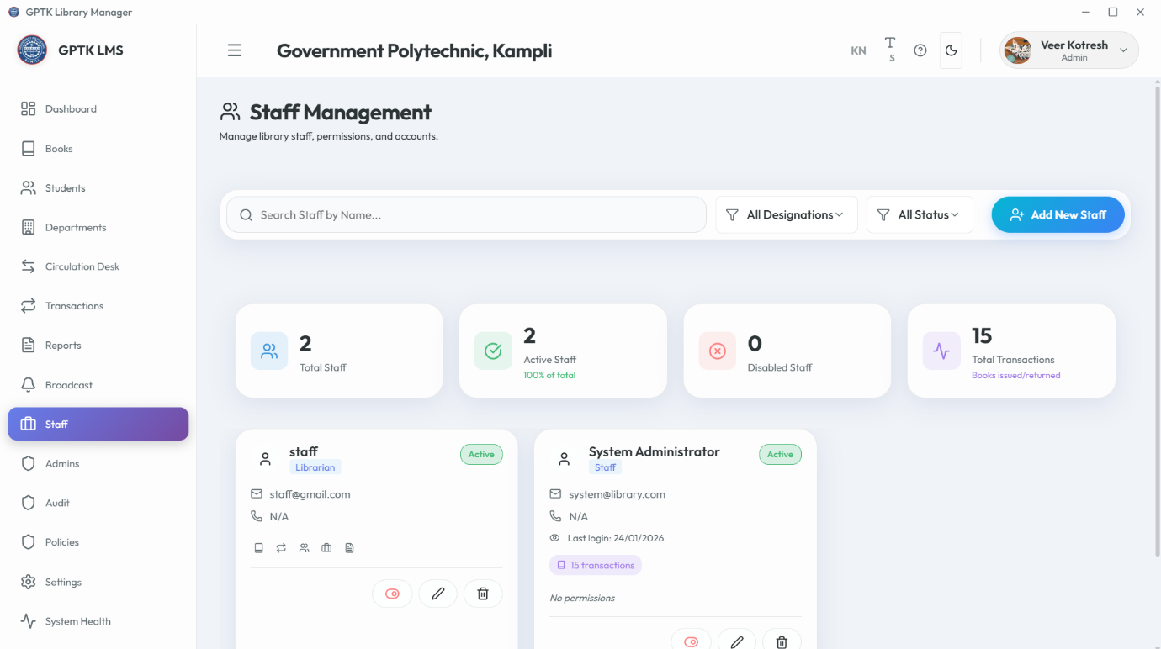

## Adding Staff

1. Click **Add Staff**.
2. **Role Selection:**
   * *Librarian:* Full Catalog & Student access.
   * *Assistant:* Circulation Desk only.
3. Set Credentials.

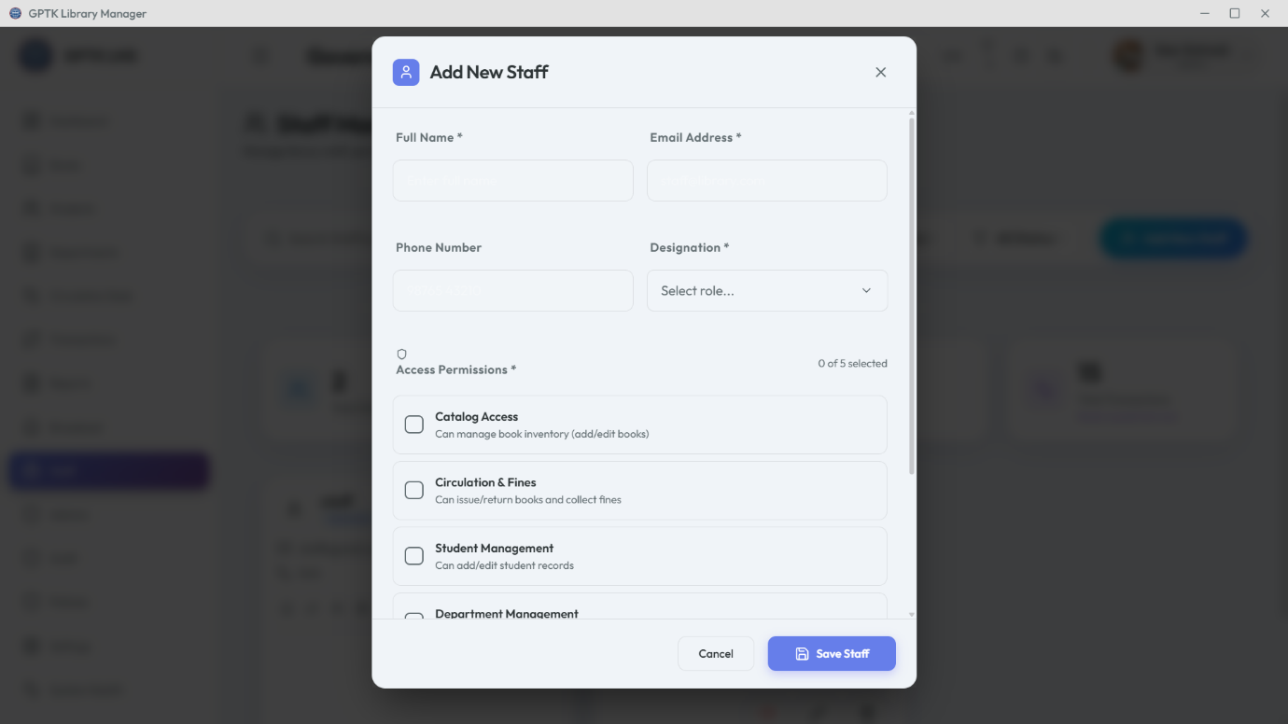

## Account Maintenance

Update contacts, reset passwords, or deactivate accounts.

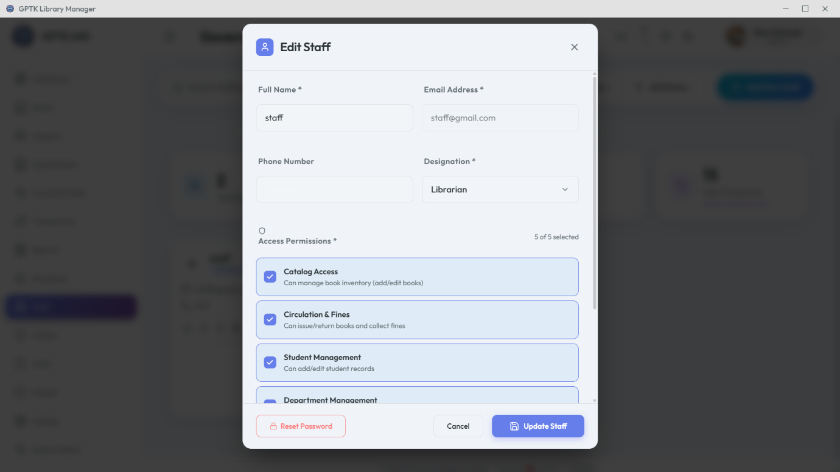

# 13. Admin Management

# System Administration

The command center for Super Users. Unrestricted access to settings, audits, and critical records.

**Security Warning:** Only grant Admin access to trusted senior personnel. Admins can permanently delete records.

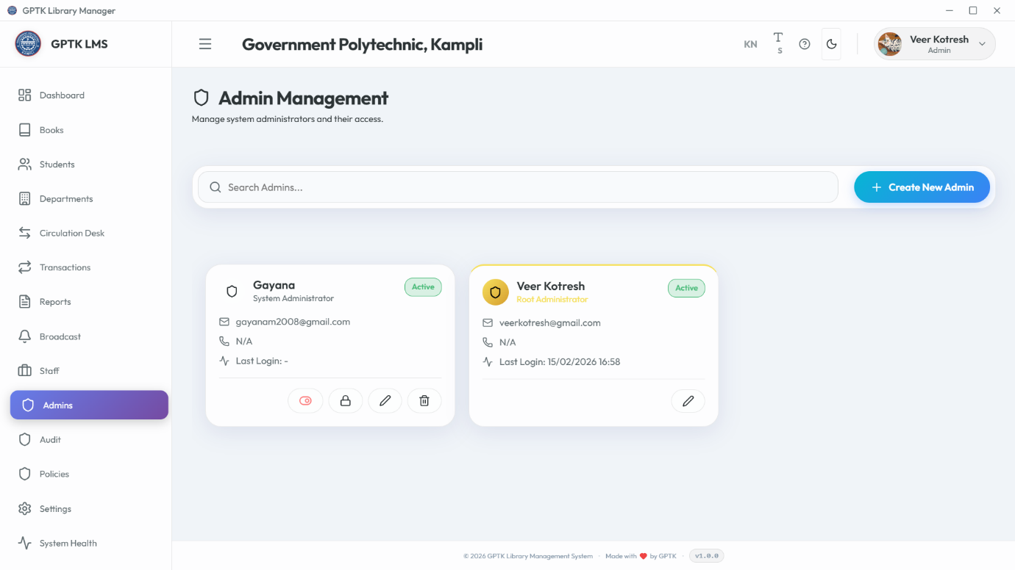

## Creating Admins

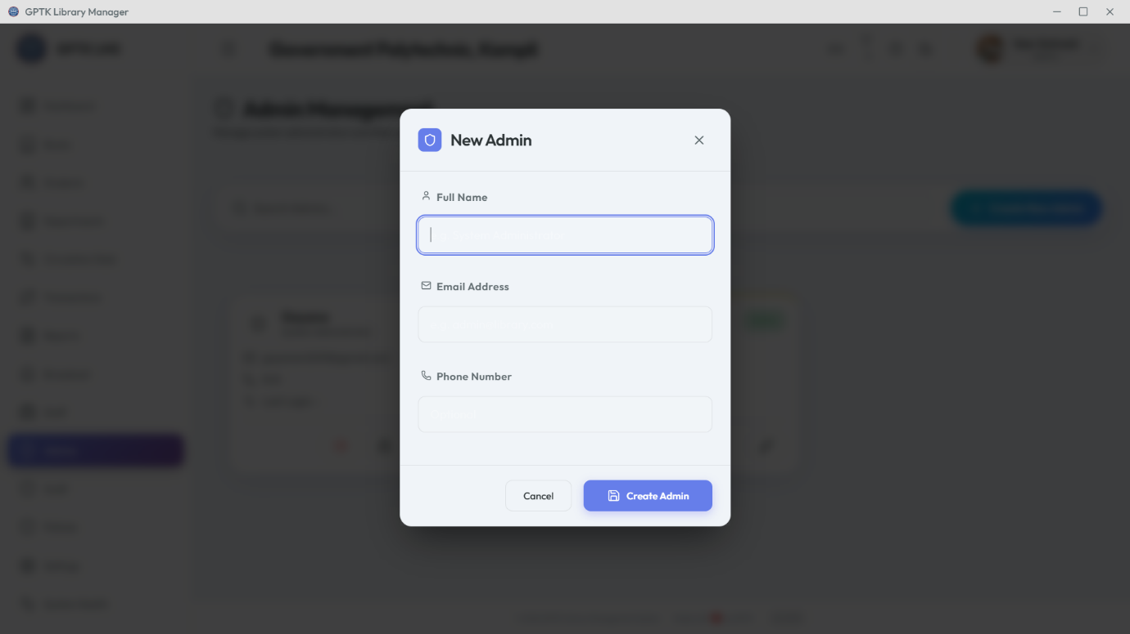

## Managing Credentials

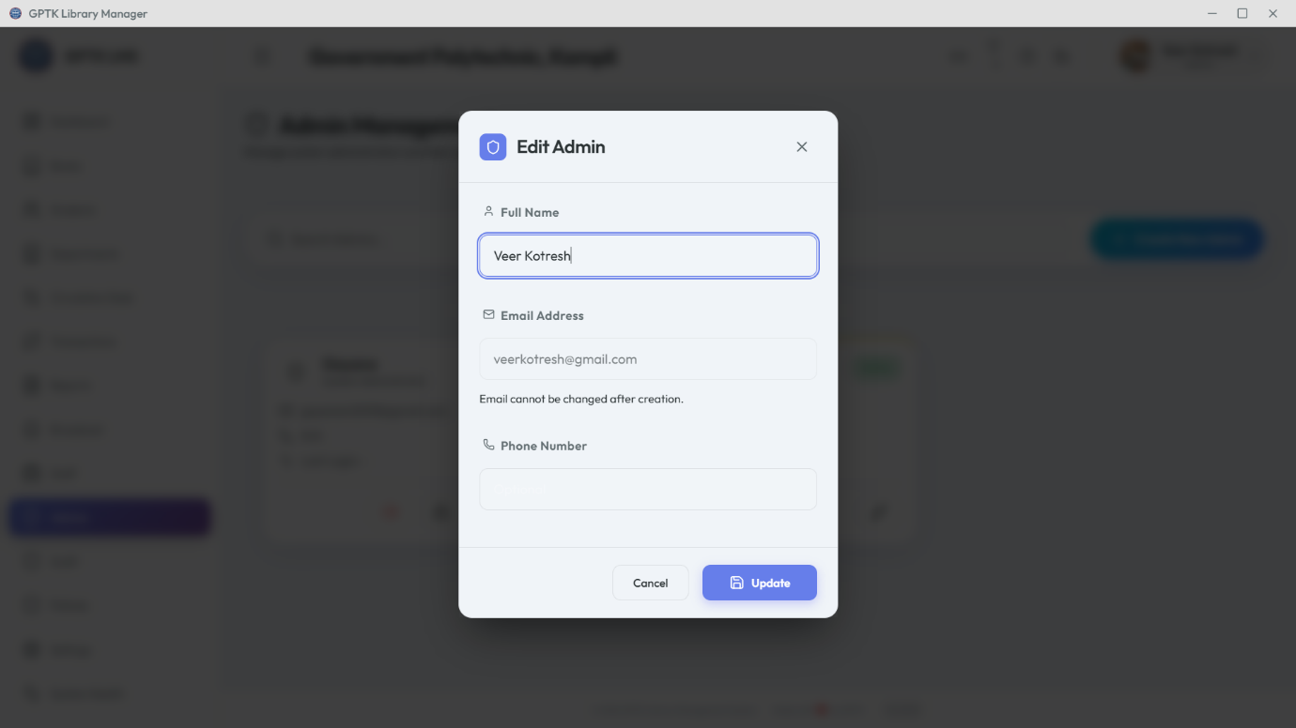

Note: The Root Admin cannot be deleted.

# 14. Audit Logs

# Security & Accountability

An immutable record of every critical action. Primary tool for security monitoring.

## 1. Activity Monitoring

* **Actor:** Who performed the action.
* **Action:** What operation (e.g., Deleted Book).
* **Target:** What record was affected.
* **Timestamp:** Precise time.

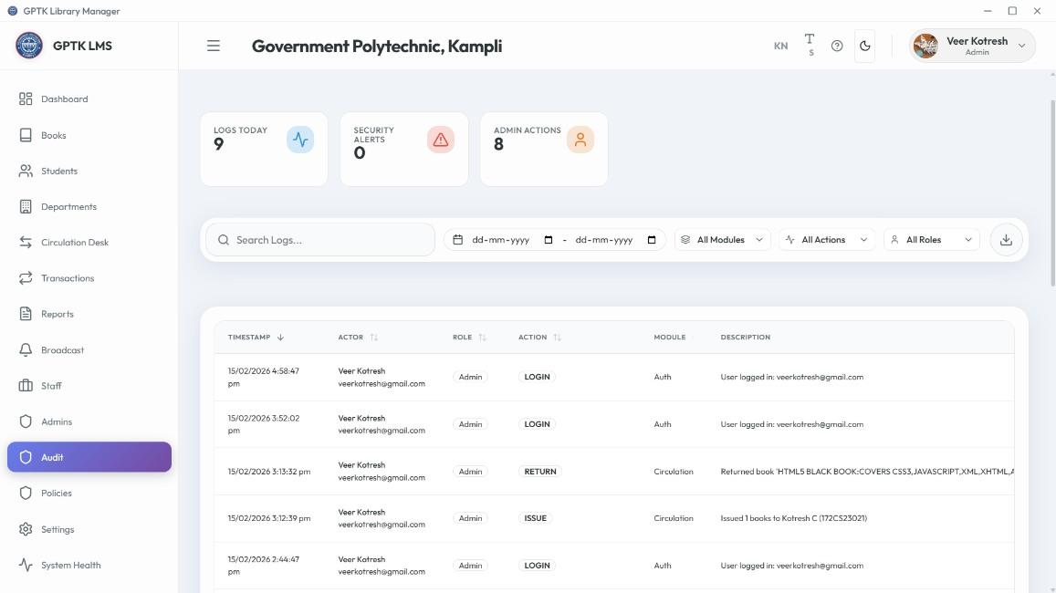

## 2. Compliance Export

Export full logs for external auditing.

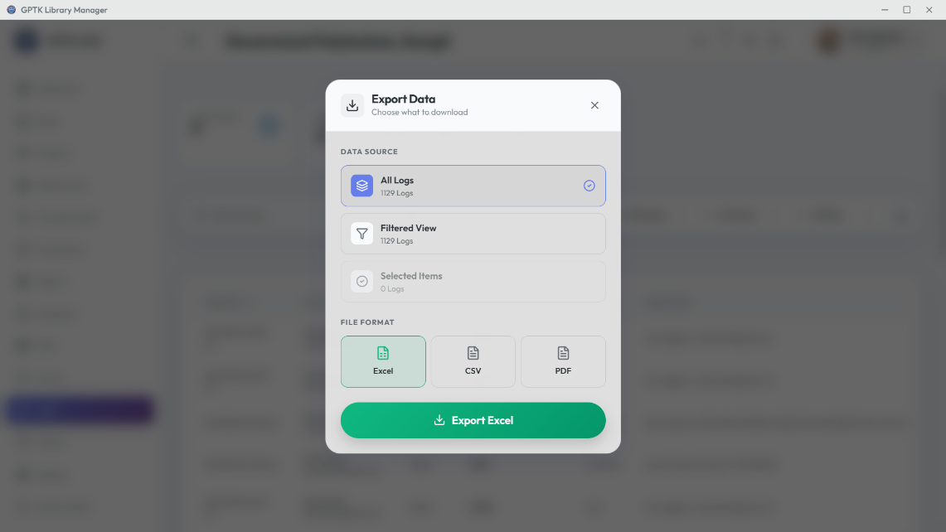

# 15. System Policies

# Operational Rules Engine

Define logic governing library operations, from loan limits to fines.

## Circulation Rules

Set max books per student, loan periods (days), and renewal limits.

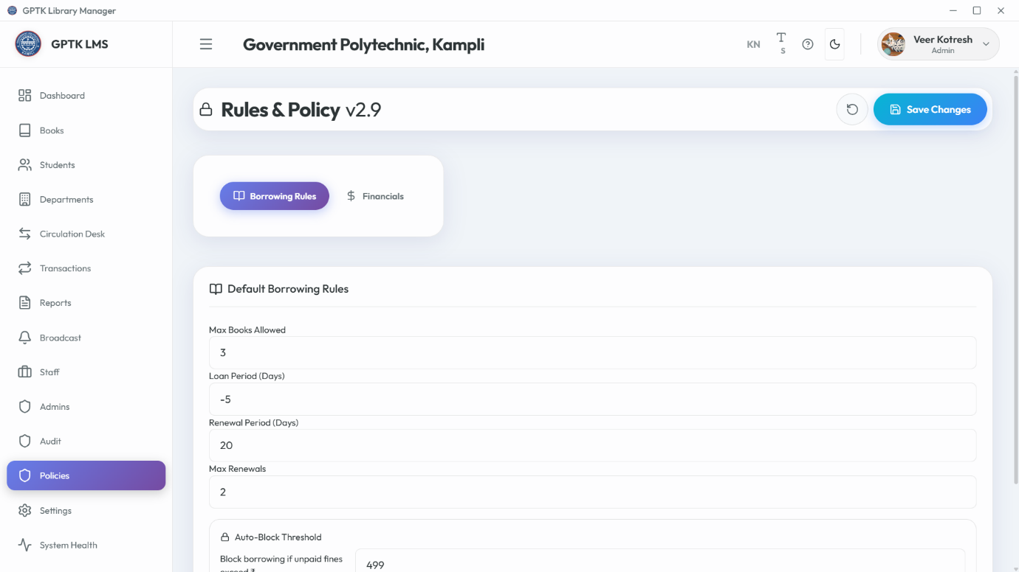

## Financial Rules

Configure fine amounts per day, grace periods, and currency symbols.

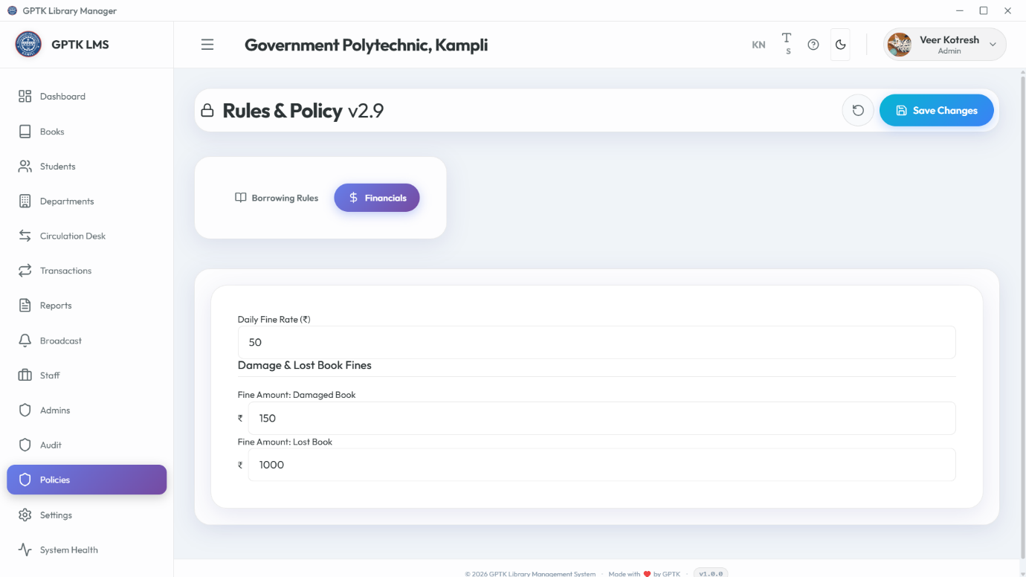

# 16. System Settings

# Global Configuration Hub

Control center for infrastructure, security, and automation.

## 1. Appearance

* **Theme:** Light/Dark Mode.
* **Language:** English/Kannada.
* **Scaling:** Font size adjustments.

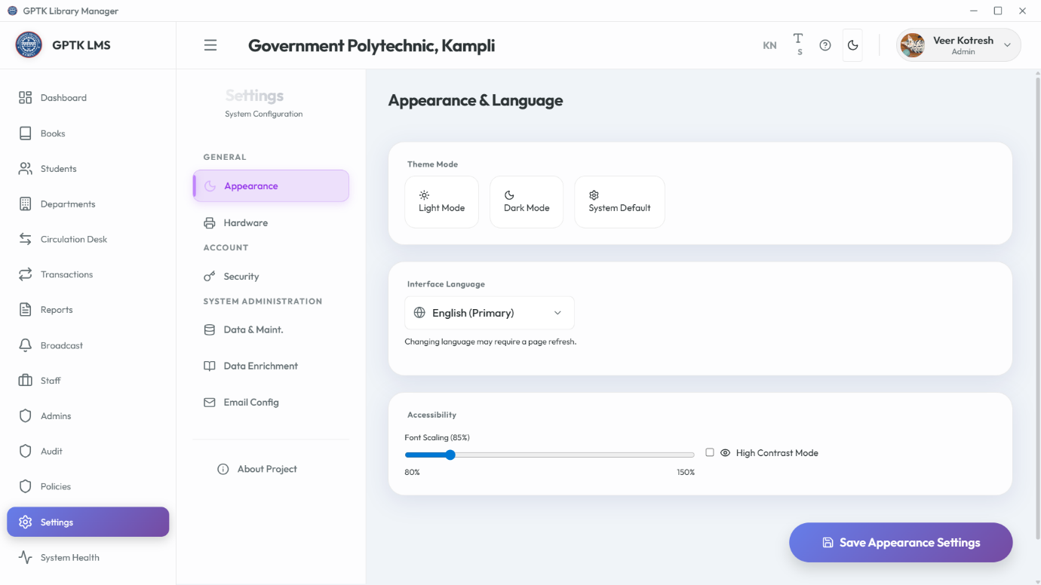

## 2. Hardware

Configure barcode scanners and run device health checks.

* **Scanner Config:** Set your scanner to append an 'Enter' key suffix for auto-submit.
* **Testing:** Use the built-in diagnostic tool to verify scan speed and accuracy.

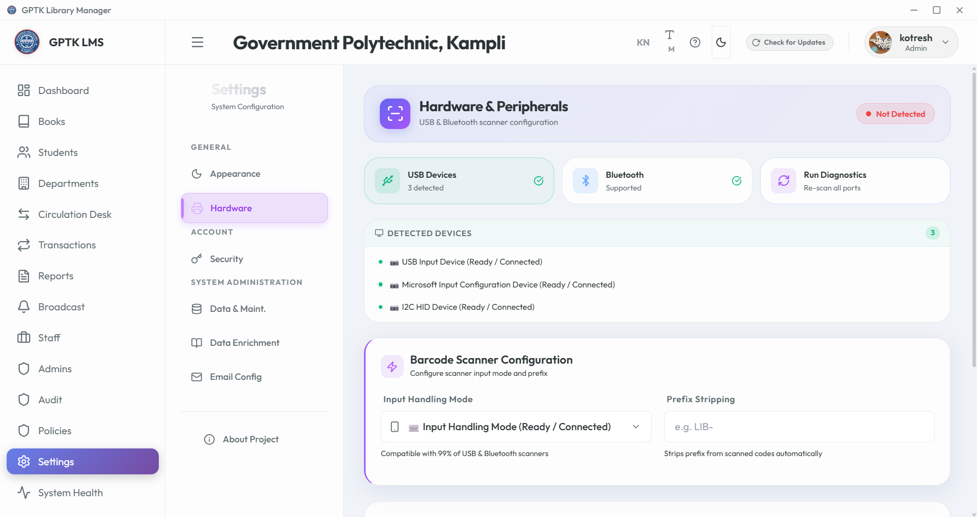

## 3. Security

Change admin passwords and configure session timeouts.

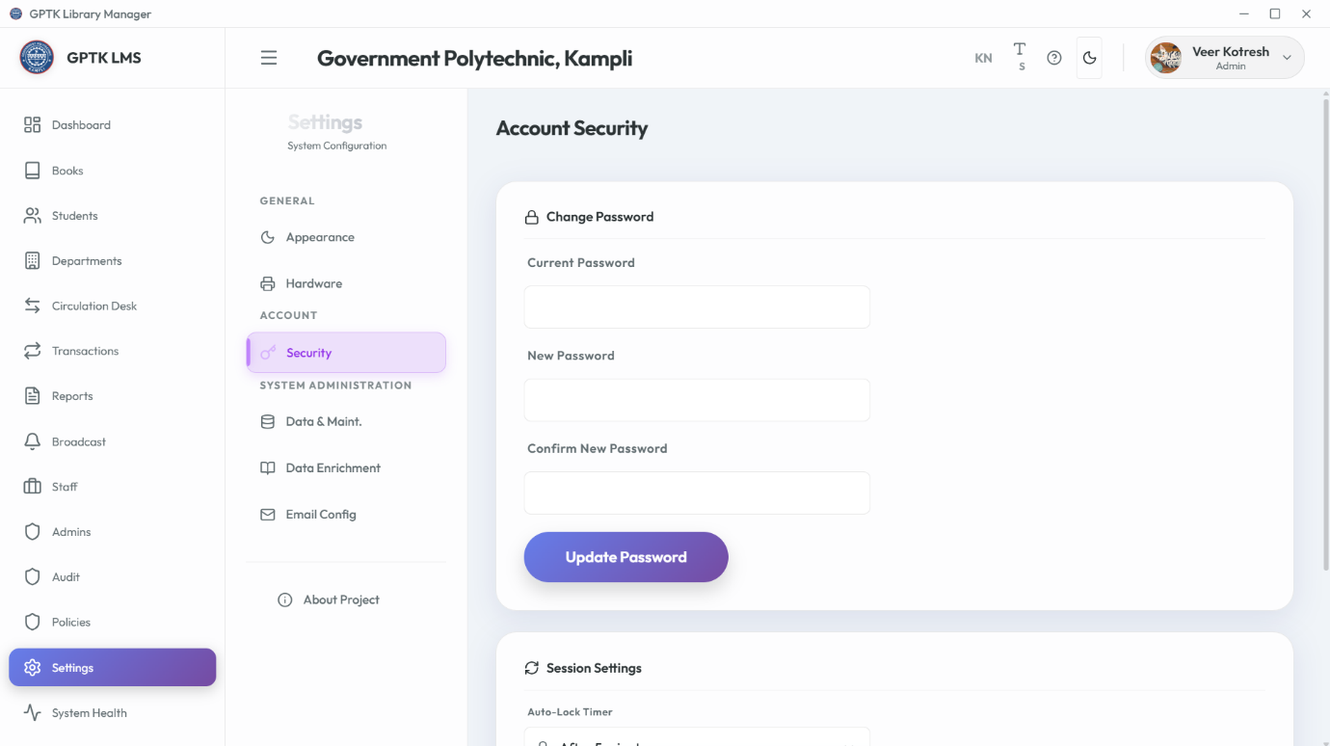

## 4. Data & Maintenance

Manage backups, cloud connections, and cache clearing.

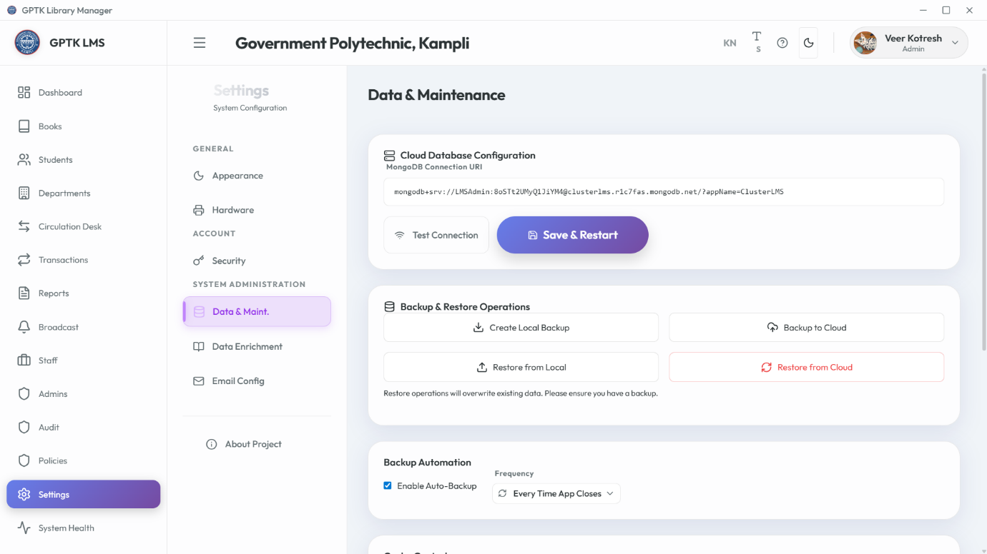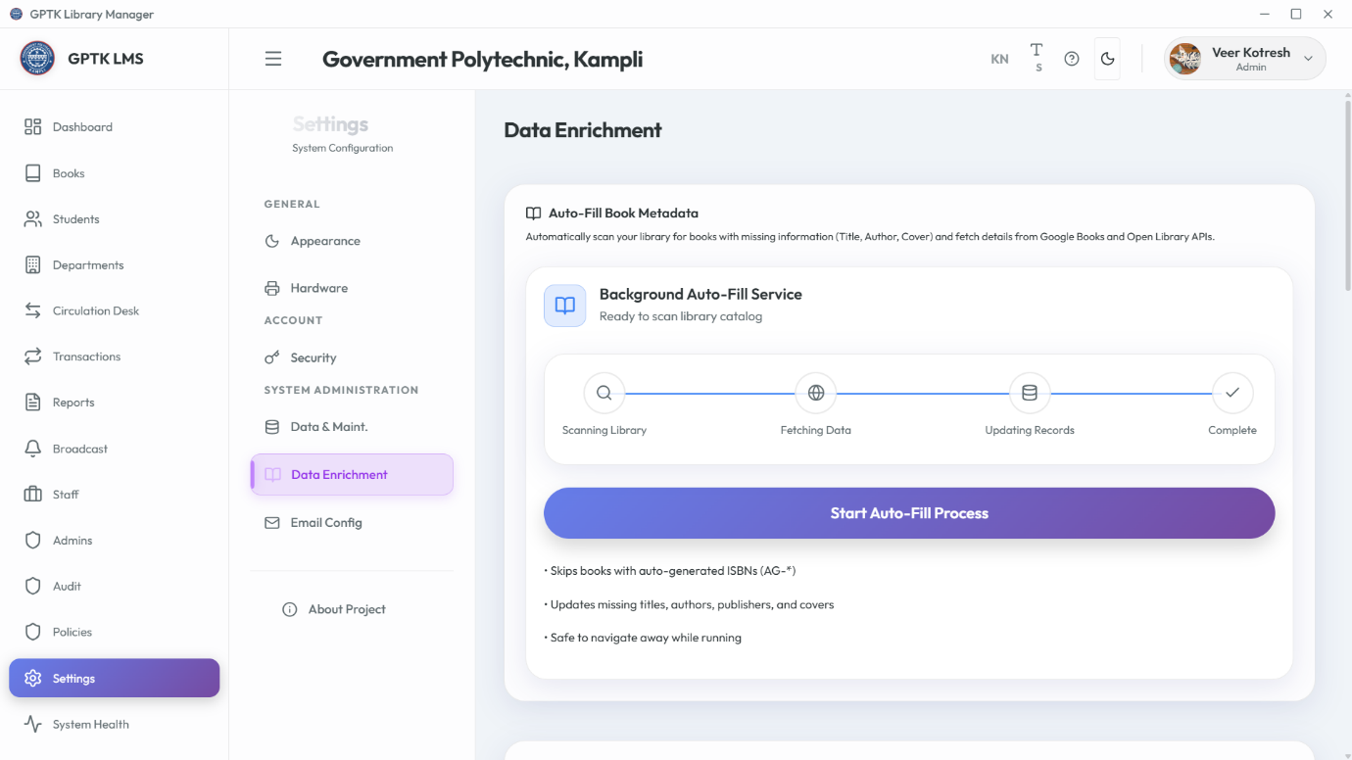

## A. Creating a Cloud Database (MongoDB Atlas)

Follow these steps to generate your unique connection string:

1. Go to [MongoDB Atlas](https://www.mongodb.com/cloud/atlas/register) and sign up for a free account.
2. **Create a Cluster:** Select the "Shared (Free)" plan and click **Create Cluster**.
3. **Database Access:**
   * Go to *Security > Database Access*.
   * Click **Add New Database User**.
   * Choose "Password" authentication. Enter a Username (e.g., admin) and a Strong Password.
   * Click **Add User**. (Remember these credentials!).
4. **Network Access:**
   * Go to *Security > Network Access*.
   * Click **Add IP Address**.
   * Select **Allow Access from Anywhere** (0.0.0.0/0) for easiest access, or add your specific static IP.
   * Click **Confirm**.
5. **Get Connection String:**
   * Click **Connect** on your Cluster dashboard.
   * Select **Drivers**.
   * Set Driver to **Node.js** and Version to **4.1 or later**.
   * Copy the connection string provided (e.g., mongodb+srv://<username>:<password>@...).

**2. Connecting to MongoDB**

The system supports both local and cloud database connections. To configure the **Mongo URI**:

1. Navigate to **Settings > Data & Maintenance**.
2. Locate the "Database Connection String" field.
3. Enter your URI in the standard format:
   * **Localhost:** mongodb://localhost:27017/gptk_library (Default for offline use).
   * **Atlas/Cloud:** mongodb+srv://<username>:<password>@cluster0.mongodb.net/gptk_library?retryWrites=true&w=majority
4. Click **Test Connection** to verify reachability.
5. Click **Save** and restart the application.

**Network Access:** If using a cloud database, ensure your current IP address is whitelisted in the MongoDB Atlas dashboard (Network Access > Add IP Address).

## 5. Email Configuration

Setup SMTP for automated email notifications.

**Generating a Gmail App Password**

To use Gmail as your SMTP provider, you must generate a secure "App Password" (your regular Gmail password will not work due to security restrictions).

**Prerequisite:** You MUST enable**2-Step Verification** on your Google Account first.

1. Log in to your **Google Account** and go to [Security settings](https://myaccount.google.com/security).
2. Under "How you sign in to Google", ensure **2-Step Verification** is ON.
3. In the search bar at the top of the settings page, type **"App passwords"** and select the result.
4. **Create Password:**
   * **Select App:** Choose "Other (Custom name)".
   * **Name:** Type "GPTK Library" and click **Generate**.
5. **Copy Credentials:**
   * A 16-character code will appear in a yellow bar (e.g., abcd efgh ijkl mnop).
   * Copy this code immediately. You cannot view it again.
6. Paste this code into the LMS **SMTP Password** field (spaces are ignored).

**Security:** Treat this App Password like your banking PIN. Never share it.

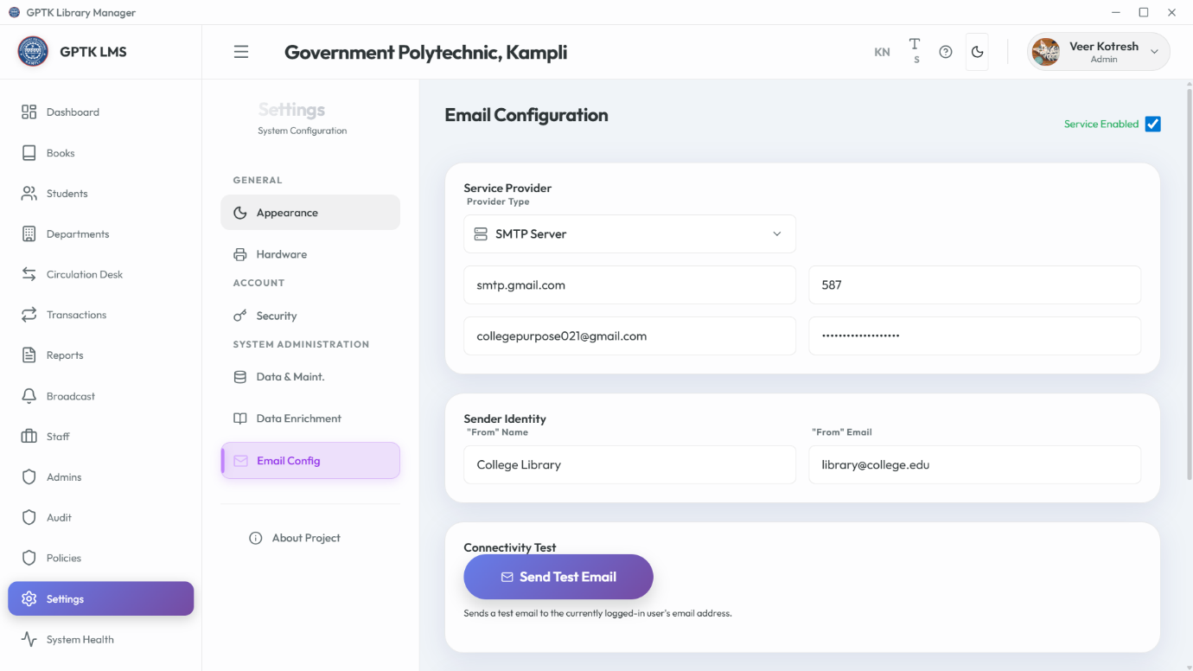

# 17. System Health

# Diagnostics Dashboard

Monitor real-time performance metrics like CPU load, RAM usage, and Disk space.

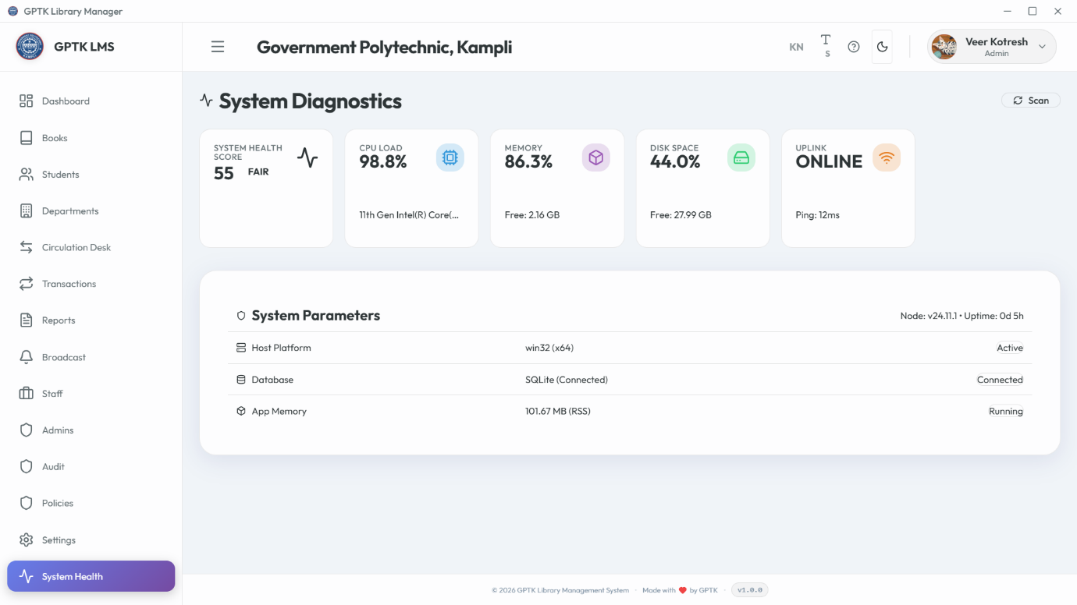

**Pro Tip:** Restart the application if memory usage remains high (>90%) for extended periods.

# 18. Public Pages

# Landing & About

The public-facing portal for visitors before login.

